

Rathfarnham Educate Together National School

Parents’ Association Manual
October 2004
Table of Contents

Introduction: How to do Everything 1
Section One: School Committees 2
Executive Committee 2
Board of Management 2
Parents’ Association 2
RETNS Parents’ Association 3
Section Two: Parents’ Association Meetings 4
Annual General Meetings 4
Regular PA Committee Meetings 7
Appendix 2.1: AGM Poster for notice board and photocopy for school bags 8
Appendix 2.2: AGM poster 9
Appendix 2.3: Reminder for schoolbags 10
Appendix 2.4: Treasurer’s Report 11
Appendix 2.5: Chairperson’s Address RETNS PA AGM 2003 12
Appendix 2.6: Extracts from Department of Education guidelines regarding election of parent representatives to Board of Management 17
Appendix 2.7: Sample agenda for PA committee meeting 20
Appendix 2.8: Contact details for committee 21
Section Three: Extra Curricular Activities 22
Phase One: Preparation 22
Phase Two: Organisation and Setting Up 24
Phase Three: Day to Day Management 29
Appendix 3.1: Letter confirming insurance cover 30
Appendix 3.2: Timetable 31
Appendix 3.3: Note to Parents 32
Appendix 3.4: Code of Behaviour 33
Appendix 3.5: Class vouchers 34
Appendix 3.6: Waiting list 36
Appendix 3.7: Excel spreadsheet of extra curricular enrolment 37
Appendix 3.8: Teacher guidelines 38
Appendix 3.9: Ethos guidelines 40
Appendix 3.10: Supervisor guidelines 41
Section Four: Coffee Morning 42
Appendix 4.1: Layout of Hall 45
Section Five: Report on Intercultural Day, 8 June 2003 46
Introduction 46
Decisions to make at the start 47
Tasks in the run-up to the event 49
Recommendations for the Future 52
Appendix 5.1: Guidelines for Stall Leaders 54
Appendix 5.2: Donations 56
Appendix 5.3: Letters to Donors 57
Appendix 5.4: Can You Help Flier 59
Appendix 5.5: Invitation Flier 60
Appendix 5.6: Intercultural Day Programme 61
Appendix 5.7: Article for School Newsletter 63
Section Six: Annual Events 65
New Junior Infants Parents’ Night 65
School Social Event – Fun Day 67
School Sports Day – Obstacle Course 70
Other Annual Events 72
Gifts 72
Appendix 6.1: Can You Help at the Fun Fair Flyer 73
Appendix 6.2: Fun Fair Flyer 74
Appendix 6.3: Fun Fair Posters 75
Appendix 6.4: Schedule of Events 76
Appendix 6.5: Teacher’s Quiz 77
Appendix 6.6: Floats 78
Appendix 6.7: School Sports Day Letter 79
Acknowledgements 80

Welcome to the RETNS PA Manual


(otherwise titled “How to do Everything”)

Introduction:
How to do Everything
Welcome to the Rathfarnham Educate Together National School Parents’ Association manual.
Our PA was formed in 1998 and over the years the committee has changed and grown with the school. Like every Parents’ Association, we have been involved in organising and running many events for our school. We have made some mistakes along the way, and we have learned many things. Two of our proudest achievements are the Intercultural Day we held in June 2003 and our ongoing programme of extra curricular activities.
Each year as new parents join and other parents leave, lessons from previous years have to be passed along to the new committee. In 2002, the committee felt it would be helpful for future committees if we kept some notes on how we organised the winter coffee morning, to make things easier for the next time. We were so pleased with this bright idea that we decided to put together a manual on all of our activities.
And here it is: a manual of how we do (almost) everything. We hope to keep it updated and add new sections as we tackle new projects.
This manual is broken up into 6 sections:
- School committees: This is a short outline of the role of three different committees in our school including our Parents’ Association.
- PA meetings: This chapter outlines how we run an annual general meeting and how we organise our regular monthly PA meetings.
- Extra curricular activities: Our PA runs an extensive programme of extra curricular activities. The programme has grown over the years and in January 2004 we offered 17 different activities. This section outlines how we organise classes, teachers, supervisors and enrolment.
- Coffee morning: This section has notes on how we organise a large coffee morning in our school hall. This type of coffee morning usually involves a performance by the children, which ensures a large turn-out of parents.
- Intercultural Day: This was a whole school project involving students, teachers and parents. This sections describes how the PA was involved.
- Annual Events. There are some recurring events to which we assign parents from a specific class. Junior Infants help with the meeting for parents of Junior Infants joining the school the following year, Second Class organise the obstacle course on sports day, Fifth Class organise the Sixth Class leaving party.

Notes:
The word “parents” used throughout this document also includes guardians.
The committee of the Parents’ Association represents all of the parents in the school. In this document, we will generally say “Parents’ Association” or “PA” to mean “committee of the Parents’ Association.”

Section One:
School Committees

Executive Committee
The Executive is responsible for providing the buildings for the school and is the caretaker of the ethos of the school, as set out by the overall governing body of Educate Together schools.
The members of RETNS Ltd. elect a committee at an Annual General Meeting (membership of RETNS Ltd. costs €10 annually). This executive committee acts as Patron for the school. (In a Catholic National School, the Patron would be the Bishop.)

Board of Management
The Board of Management is responsible for the day to day running of the school.
The Board of Management has eight members: the school Principal, a teacher representative, two nominees from the Patron, two representatives from the Parents and two representatives from the community.

Parents’ Association
The Parents’ Association represents all of the parents in the school. The PA committee is elected by the parents at an Annual General Meeting, which all parents can attend.
The aims of the Parents’ Association are:
….. to represent the views of parents
….. to inform parents of developments in education and in the school
….. to foster co-operation between parents, teachers and school management.

RETNS Parents’ Association
The aims of the Parents’ Association are:
….. to represent the views of parents
….. to inform parents of developments in education and in the school
….. to foster co-operation between parents, teachers and school management.

Here is how we attempt to fulfil those aims:

Represent the views of parents
- The Annual General Meeting is an excellent opportunity for parents to meet and discuss their views.
- The PA should have regular meetings at which parents’ views can be brought up. The members of the committee should talk to other parents and bring any ideas, suggestions and opinions to committee meetings. These meetings include the Annual General meeting, coffee mornings and evening meetings with guest speakers.
- We have found it helpful to have at least one parent from each class on the committee.

Inform parents of developments in education and in the school
- The Parents’ Association is a member of the National Parents Council (Primary). This is an excellent organisation which provides a lot of information to parents. Their website is www.npc.ie.
- A regular newsletter is a great way to communicate with the parents. Our school has decided that all school committees and staff should contribute to one newsletter, rather than each group having their own. This should be produced each term.

Foster co-operation between parents, teachers and school management
- We have regular meetings with the school Principal to foster two-way communication: we present parents’ views and concerns, discussing forthcoming events, and discuss ways to support the school.
- The PA should be in regular contact with the Board of Management. There are two parent representatives on the Board and the Board may ask these reps to liase with the PA on specific issues. In our case, one or both of the parent reps on the board attend regular PA meetings.
- We have found it helpful to have informal meetings between the Chairpersons of the PA, the Executive and the Board of Management. This cross-committee communication is very helpful.
- We have participated in a Joint Committee meeting with all the members of all the committees. This meeting was chaired by an outside facilitator from Educate Together and followed by a social get-together. The chairpersons, facilitator and principal met before the joint meeting to prepare the agenda.

Section Two:
Parents’ Association Meetings

Annual General Meetings

Find a Venue
We generally use a room in the school. We have found that using a classroom is better than using the school hall, as the hall is too big for a small group and it can be very cold in the evening time.
When using the school, you need permission from the principal and you need to be sure that there will be someone available to open and close the school.
If you are using a classroom, talk to the teacher beforehand.
Before you move any chairs or furniture … make a map of the room! This will help when you are trying to put everything back where you found it.

Set a Date
When looking for a suitable date for the Annual General Meeting some things to consider are:
Are there other activities in or near the school at that time?
Will there be parking available?
Will there be someone available to open and close the school?
Is it a school day? (This seems obvious, but check to see that it is not a school planning or teacher training day)

Advertising
You will need to advertise the AGM early and often.
Notes should go in school bags at least three weeks before the AGM and then a reminder note should go in the bags about 3 days before.
Posters should go on the notice board, and indeed anywhere that parents will see them. Make different posters – use colour!
Word of mouth is most important – tell anyone you know, everyone you see and anybody you think might be interested. Parents are more likely to attend these events if they know someone else who is going.

Attracting participants
If possible, keep the length of the AGM short – no more than 45 minutes if possible.
We usually arrange a guest speaker; this helps to attract more parents to attend. The speaker will begin as soon as the meeting is over. Again, the speaker should limit time to 45 minutes (or perhaps 1 hour).
If the budget allows, a glass of wine (or a cup of tea) after the speaker will give parents a chance to mingle. This is also another excellent opportunity for the members of the committee to get parents’ views on the upcoming year.

AGM Business
The AGM is chaired by the Chairperson of the Parents Association. The order of business is as follows:

Committee Reports
There are usually three reports at Parents’ Association Annual General Meetings:

Secretary’s Report
The secretary may read the minutes of the previous AGM and then present a report on the events of the past year. If you prefer, you can pass out photocopies of the minutes and these can be incorporated into the Chairperson’s address.

Treasurer’s Report
The Treasurer prepares a written report showing all of the income and outgoings since the previous report. Photocopies of the treasurer’s report are made available to everyone who attends. The Treasurer then makes a short presentation to the meeting and is available for any questions from the floor.

Chairperson’s Address
The Chairperson’s report may cover events of the past year, upcoming events, and any issues concerning parents.

Elections

Election of committee members
There is no set number of members for the committee of the Parents’ Association. If there is a huge interest in membership of the committee, an election may be held. In practice, an election is not usually necessary – those who are willing to put their names forward for the committee will be accepted onto the committee.
The Chairperson should thank committee members who are standing down and name those who are prepared to stay on. The committee should consider approaching possible new members in advance of the AGM to explain what the PA does and to see if they would join.
We have found it helpful to have at least one parent from each class on the committee.
The committee will choose its chairperson, secretary, treasurer etc at its first meeting, so these positions do not need to be chosen at the AGM.

Election of Representatives to Board of Management
Under Department of Education rules, school Boards of Management must be replaced every four years. There are two parent representatives on the Board of Management and these must be elected by the parents. The AGM is the best time to do this.
The Department of Education sets out the correct way to elect parent representatives. In essence, these are:
- The Executive Committee (the Patron of the school) calls the election
- Nominations are called for from the parents
- If there are more than two nominations, an election is held with a secret ballot
- There must be one female and one male parent representative.

Any other business
This is the time to open up the AGM to questions / suggestions from the floor. It is the best time of the year to check in with parents on whether they are satisfied with the work of the PA and if there are new issues they wish the committee to deal with.

Guest Speaker
After the business of the AGM is concluded, it is time for the guest speaker.

Refreshments
A glass of wine or a cup of tea will allow all participants to relax, mingle and get to know one another. This is an important time for the members of the committee to talk to parents, to further the aims of the PA.

Regular PA Committee Meetings

Dates
We hold meetings generally once a month during the school year. In discussion with the members of the committee on the first meeting after the AGM, the committee decides which days are best to meet and sets out the calendar for the year. Every member of the committee then knows the dates and is responsible for their own attendance.
If committee members find it necessary, one member of the committee may be allocated to give telephone reminders of upcoming meetings – we have found text messaging to be very efficient.

Agendas
It is helpful if the agenda for the upcoming meeting is circulated one week before the meeting. Many committee members have email nowadays, which is the easiest way to circulate agendas.
Issues to be discussed have included the extra-curricular programme, guest speakers, coffee mornings, concerns of parents, etc.

Timing
Keeping meetings running to a reasonable timetable is perhaps the most difficult task of the chairperson. We have as yet to find the best way to do this! Each member of the committee should be able to put forward their point of view, but equally the meeting should not go on all night. Two things which have helped our meetings to run more effectively are:
- Meetings start on time. No exceptions.
- Agendas are prepared by the Chairperson or the Secretary and circulated before the meeting; members of the committee can have an item put onto the agenda.

Minutes
Minutes of all committee meetings are taken by the secretary. These are circulated as soon as practicable after the meeting.
Many committee members have email nowadays, which makes this task a great deal easier for the secretary. Otherwise, minutes can be put in a child’s schoolbag or posted.

Committee Lists
Keeping an up to date list of committee contact details is very important.
We regularly print out contact lists for committee members. We also forward this list to the principal and the Board of Management.
The internet can also be a useful place for contact information. You can create a group in Hotmail, which all members can access. This allows you to post messages, keep an up to date contact list, post minutes and agendas. (http://groups.msn.com) Our committee experimented with this for one year, but found that it only works well if all members of the committee can access it regularly.

Appendix 2.1: AGM Poster for notice board and photocopy for school bags

Rathfarnham Educate Together National School
Parents’ Association
Annual General Meeting

Tuesday 4 November 2003
8:00 p.m.
Order of business:
- Parents’ Association AGM
- Election of Parent Representatives to the Board of Management
- Antoinette Rossiter will then speak on: “Getting on with others –
The world of children’s relationships”
- A glass of wine to follow

Election of Parent Representatives to the Board of Management:
The Patron has requested us to arrange for nominations and election of two parent representatives to the new Board of Management.
On the night of the AGM, nominations will be sought from parents for persons to stand for election as parent representatives on the Board. Nominations will be invited for both a mother’s panel and a father’s panel.
If there is only one nominee for either panel, the nominee(s) shall be deemed to be elected.
If more than one nomination is received for either of the panels, a secret ballot shall be held at the meeting. Each person voting shall have one, non-transferable vote for each panel.
“Parent” includes a foster parent, a guardian appointed under the Guardianship of Children Acts, 1964 to 1997, or other person acting in loco parentis who has a child in his or her care subject to any statutory power or order of a court and, in the case of a child who has been adopted under the Adoption Acts, 1952 to 1998, or, where the child has been adopted outside the State, means the adopter or adopters or the surviving adopter.

Interested in putting your name forward for nomination as a parent representative on the Board of Management?
Contact Liza Toye 086 8313369

Appendix 2.2: AGM poster

Rathfarnham Educate Together National School
Parents’ Association

Annual General Meeting

Tuesday 4 November 2003
8:00 p.m.

Order of business:

- Parents’ Association AGM
- Election of Parent Representatives to the Board of Management
- Antoinette Rossiter will then speak on: “Getting on with others –
The world of children’s relationships”
- A glass of wine to follow

Appendix 2.3: Reminder for schoolbags

 | A friendly reminder!

The RETNS Parents’ Association AGM will be held on Tuesday, 4 November 2003
at 8:00 p.m. in the school.

Antoinette Rossiter, psychologist,
will speak on the topic
“Getting on with others – The world of children’s relationships”

Appendix 2.4: Treasurer’s Report

Rathfarnham Educate Together National School Parents’ Association
Balance as at 30 September 2004

Income
Balance Forward | 964.53
Coffee morning and raffle income | 606.24
Extra Curricular – income | 14274.10
Training – NPC refund | 193.70
Total | 16038.57
Expenditure
Insurance | 150.00
NPC affiliation | 85.00
Extra Curricular – Teachers | 11130.80
Extra Curricular – Supervisors | 940.00
Extra Curricular – Refund | 131.00
Volleyball Equipment | 344.48
Art materials | 343.67
Coffee morning – school donation | 560.00
Coffee morning – expenses | 43.86
Speakers | 200.00
AGM expenses | 224.26
Stamp Duty | 22.60
Teacher’s Gifts | 373.98
Committee Expenses | 301.20
PA training | 253.70
NPC Cadbury Quiz fee | 15.00
Surplus – bank | 919.02
Total | 16038.57
Current account balance brought forward | 964.53
Income | 15074.04
Total | 16038.57
Outgoings | 15119.55
Net Position | 919.02

Appendix 2.5: Chairperson’s Address RETNS PA AGM 2003

Introduction
Welcome to the fifth Annual General Meeting of the RETNS Parents’ Association. The first AGM was held in 1999, so our PA has now been running for six years – initially with Úna Hennessy as Chairperson, then with Helen Conway. This year it has been my turn as Chairperson and it has certainly been a very busy year.
We held 7 meetings with Paddie (our school principal), where representatives of the PA brought many different topics to her attention. For example:
Coffee mornings
Newsletters and Notices
Supervision during indoor breaks
Soap in the bathrooms; provision of a soap dispenser
Homework guidelines
Parking
Christmas trips
December and January costs – everything seemed to come together
Achievements book
Sports day
School dress code
Junior Infants starting times for September

Extra curricular activities
Inter cultural event

We organised quite a few “events” this year, including:
13 December | Christmas Coffee Morning (which raised €560 for the school). This was a tremendous success, with all of the children participating and nearly all of the parents attending. I particularly enjoyed the mince pies!
22 March | Crisis Training with Will Marling. This was attended by most of the members of the PA committee and all who participated found it very thought provoking.
13 May | Linda Doherty gave a talk for the PA on the subject of improving our children’s self esteem. This was a very well attended meeting – not just the usual faces!
29 May | Speech and Drama performance – by all of the children involved in the Extra Curricular Speech & Drama classes
8 June | Inter Cultural Day! – There was a great show of community spirit – children, teachers, parents, neighbours – everyone participating and really enjoying a terrific day. And to top it all off, €1700 was raised for the Ethical Education and SPHE programmes. There were around 50 volunteers, which included parents from all the classes, not just members of the PA committee. It was the highlight of my year, I know that much.
September | Three coffee mornings were run in September for the Junior Infants parents.
We have also worked on some other projects, for instance:
- Provision of soap dispenser in the Junior/Senior Infants toilets; this was eventually installed at the end of April 2003.
- Putting together a folder for future committees with info like the structure of the school, function of the PA, how ET works, how NPC works, how to organise extra curriculars, coffee mornings, picnics, etc. We call it “How to do Everything”
- We are affiliated to the National Parents Council, and Uwe from our school is the Treasurer of the South Dublin Branch of NPC
- I attended the Educate Together Ethos Conference in February, and presented a detailed report to the Executive and a shorter one to Paddie for the newsletter
- Julia Rowan (a member of our PA committee) attended the Junior Infants welcoming meeting and Paddie invited her to address the parents and tell them about the role of the PA.
It would not be a committee if we did not have long and heated discussions! Some of the things we have discussed at length include:
- School homework policy
- School safety policy (2 members of the PA worked with members of the BOM on establishing a policy)
- Fund raising. (Parents would like to be informed what money raised is used for – not because we don’t believe it is used well, but to understand how fundraising contributes to the day-to-day running of the school.)
- Parking
- Dress code
- Creating a list or database of parent skills
- Running PA meetings on a more effective basis
Many of these items were also discussed with Paddie. Some of these items will be brought up again at the next Parents’ Association meeting; parking is a perennial discussion point, and we will be working with Paddie and the Board over the next few weeks in a concerted effort to improve parents’ awareness of the parking problem.
Communication has been a constant theme of our PA meetings. We need to find an effective way of communicating with all parents; school newsletters have been a bit sporadic, the school website is in need of new information. And of course notices in schoolbags are not always delivered. We agreed with Paddie at our last meeting that all notices will be posted on the Notice board (down by the staff room), as well as being put into bags.
Extra Curricular Programme
You are all aware of the extracurricular programme that is available to our children.
It has been running for 6 years now and I think you will all agree that is fantastic for our children to be able to avail of such a wide range of activities without having to leave the school premises. This success is due in no small way to the commitment of the teachers involved, and also to the hard work put in by the PA committee. We are very proud of the programme, and are constantly working to add to it or improve it.
On top of the day-to-day running of the Extra Curricular Activities, this year we also worked very hard on streamlining the sign up process, so that parents no longer need to queue for hours – we also thought it would be nice to have a cup of coffee after the queuing. We have experimented with changing the sign up times – first to Saturday morning, and then to Friday morning; we would very much appreciate your comments on this change, was it a good idea or would parents prefer to go back to an evening sign up?
Procedures were put in place this year for fire drills and correct safely procedures during extra curricular times; we also prepared new “teacher packs” for the extra curricular teachers. These packs had some information about the ethos of the school, as well as explaining things like the school’s no sweets policy.
Fund Raising committee
One of the members of the PA committee is also a member of the fund raising committee, and he was available to attend any of their meetings, to bring us any feedback, requests, etc.
Executive committee
As you know, the executive committee is an important part of our school. They are the patron body of the school and they are in charge of the ethos of the school. If you are interested in joining the executive committee, they would be delighted to hear from you.
Treasurer’s Report
Our Treasurer this year has been Lynda Langan and she will give a short financial report for the year ending September 2003.
Election of Parent Representatives to the Board of Management
The Patron has requested us to arrange for nominations and election of two parent representatives to the new Board of Management.
In a moment I will ask you to nominate and second parents for a mother’s panel and a father’s panel. If there is only one nominee for either panel, that nominee shall be deemed to be elected.
If there is more than one nomination for either panel, we will hold a secret ballot. Each person voting shall have one, non-transferable vote for each panel.
“Parent” includes a foster parent, a guardian appointed under the Guardianship of Children Acts, 1964 to 1997, or other person acting in loco parentis who has a child in his or her care subject to any statutory power or order of a court and, in the case of a child who has been adopted under the Adoption Acts, 1952 to 1998, or, where the child has been adopted outside the State, means the adopter or adopters or the surviving adopter.
Can we start with any nominations for the fathers’ panel …
And now for the nominations for the mothers’ panel …
Thank you.
And thank you very much to the very brave new members of the Board of Management!
Any Other Business
Now we have a few minutes for ANY OTHER BUSINESS.
Election of new Parents’ Association Committee
We will now move on to the creation of a new committee for the next year. Before the committee resigns, I would like to say a few words about them.
The aims of the Parents’ Association are
….. to represent the views of parents
….. to inform parents of developments in education and in the school
….. to foster co-operation between parents, teachers and school management.
The committee we have had this past year has been fantastic. They really have worked very hard to live up to these aims. I think we have done well with the first and third of these aims (representing parents views and fostering cooperation). Perhaps next year we can try to work more on keeping parents informed.
Several of the current members of the committee have indicated that they are willing to return to the committee and I thank them for their persistence! You are welcome to nominate yourself or nominate anybody else on to the committee – just come up and talk to me or any member of the committee We are always in need of enthusiastic parents who are willing to get in and work hard.
Although everyone on the committee does participate, I would like to extend my personal thanks to a few members of the committee for their outstanding contributions:
Frances Howlin, who has been our secretary all year and takes the most fantastic minutes, and makes sure that everyone is clear about what is being said
Lynda Langan, our treasurer – this is a huge responsibility, one that I certainly would not be able to keep a cool head over!
Anna Malone, who organises the extra curricular supervisors
Cheryl Marling, who organised the Christmas Coffee morning and the Extra Curricular Programme and made leaflets and cookies!
Adrienne Collins, who organised the Inter Cultural Day, which I must say again was a brilliant success.
And I would like to especially thank Úna Hennessy, who was the first Chairperson of the Parents’ Association and then moved on to be the parent representative on the Board of Management, and Helen Conway, who was also a founding member of the PA and then became Chairperson. Without these two tremendous people, I think we would not have the successful PA that we do, and we certainly would not have the Extra Curricular programme. Both Úna and Helen are resigning from the committee this year, and they are both going to enjoy a well-deserved rest from committee work.
I know this is outside the scope of our normal AGM, but we would like to present Helen and Úna with a token of our appreciation and give them a round of applause, please.
The committee now officially resigns.
Guest Speaker: Antoinette Rossiter
I will now introduce you to Antoinette Rossiter. Antoinette will talk about “Getting on with Others – The world of Children’s Relationships”
Summarise and close the meeting. Thank everybody for coming.

Appendix 2.6: Extracts from Department of Education guidelines regarding election of parent representatives to Board of Management



Boards of Management of National Schools
Constitution of Boards and Rules of Procedure
November 2000
2. Definitions
(d) “Parent” includes a foster parent, a guardian appointed under the Guardianship of Children Acts, 1964 to 1997, or other person acting in loco parentis who has a child in his or her care subject to any statutory power or order of a court and, in the case of a child who has been adopted under the Adoption Acts, 1952 to 1998, or, where the child has been adopted outside the State, means the adopter or adopters or the surviving adopter;

3. Constitution of Boards of Management
(a) For schools having a recognised staff of more than one teacher:
(i) Two direct nominees of the Patron.
(ii) Two parents of children enrolled in the school (one being a mother, the other a father), elected by the general body of parents of children enrolled in the school.
(iii) The Principal Teacher (or Acting Principal Teacher) of the school.
(iv) One other teacher on the staff of the school, elected by vote of the teaching staff.
(v) Two extra members proposed by those nominees, described at (i) –(iv) above, acting in accordance with the process set out at Appendix C.

4. Procedure for the election and nomination of members of Boards of Management
(a) The Patron is responsible for initiating the steps necessary for the establishment of a Board of Management in a national school. To this end the Patron requests a representative to arrange for the elections and nominations as set out in Appendices A, B and C.
(b) Except in special circumstances with the approval in writing of the Minister, or in the case of teacher-members of the Board so far as their remuneration as teachers is concerned, no member of the Board shall take or hold any beneficial interest in any property held or used for the purposes of the school or receive any remuneration for his/her services as a member of the Board.
(c) The Patron's representative will arrange for a meeting of those elected/nominated as per the procedures in Appendices A and B. The purpose of this meeting will be to agree the nomination of extra member(s), as set out in Appendix C.
(d) The Patron's representative shall communicate to the Patron the names of the persons duly elected/nominated in accordance with 3(a) or (b) of this document.
(e) The Patron shall then formally appoint the Board of Management.
(f) The Patron shall appoint one of the members so appointed as Chairperson of the Board of Management.
(g) The Patron shall communicate the names of the Chairperson and the other members of the Board of Management to the Minister, and confirm that the appointment of the members conforms to the procedures and requirements set out in this document.
Except where the Minister communicates to the contrary, within 10 days of receipt of the information at (g), the Board will be deemed to have been recognised by the Minister and shall assume office forthwith.
(h) The first meeting of the Board must be held within one calendar month of the date of recognition of the Board by the Minister.
Appendix B
Procedures for the nomination/election of a parent(s) for appointment by the Patron as parent representative(s) on the Board
N.B. The method of election of parent representatives shall be determined in consultation with the parent representatives on the outgoing Board and any parents' association in the school.
When a vacancy occurs among parent representatives, the Board of Management having consulted with the parents' association may recommend to the Patron either
the co-option as a replacement the person with the next highest number of votes from among those not elected to the Board initially or
the Board of Management may recommend a by-election to replace the parent representative.
This procedure should be used for the initial selection of a parent representative(s) and in the case of any by-election held following consultation with the parent association.
There are a choice of two procedures which can apply and are as set out at options 1 and 2.
Option 1
The Patron's representative shall arrange for a meeting of parents of children enrolled in the school. At least ten days' notice of such a meeting shall be given in writing to each person entitled to vote at such a meeting. This notification shall
indicate that at the meeting nominations will be sought from parents for persons to stand for election as parent representatives on the Board
clarify whether there will be a ballot at the meeting to elect the representatives or whether the ballot will be conducted subsequently as a postal ballot
where it is intended to have a postal ballot, indicate the latest date for return of ballot papers and the date, time and place of the public counting of votes.
At the meeting nominations should be invited for both a mothers' panel and a fathers' panel.
If there is only one nominee for either panel, the nominee(s) shall be deemed to be elected.
If more than one nomination is received for either of the panels, a secret ballot shall be held at the meeting or subsequently. Two tellers shall be appointed, one of whom may act as Returning Officer in the case of a postal ballot.
In the event of a postal ballot, the poll must close and the casting of votes take place within ten days of the meeting.
Each person voting shall have one, non-transferable vote for each panel.
The votes shall be counted in public.
The election shall be determined on a plurality of votes (i.e. the first past the post system).
The result of the ballot shall be notified to the parents and to the Patron's representative.
The voting returns from the ballot may be retained for the purposes of co-option in order to fill vacancies occurring during the life of the Board where it is decided, having consulted the parents' association, not to have a by-election.
Option 2
The Patron's representative shall arrange to have a list of the names of all the parents of children in the school circulated to each household, seeking from parents and guardians nominations of candidates for election to the Board of Management. This list should associate parent names with the classes attended by their children.
Each parent may make one nomination for the fathers' panel and one for the mothers' panel, which shall be forwarded to the Patron's representative in order that a list may be drawn up of the ten persons in receipt of the highest number of nominations for each panel.
The invitation to parents to submit nominations shall request parents to establish that the person(s) nominated are willing to stand for election.
If there is only one nominee for either panel, the nominee(s) shall be deemed to be elected.
If more than one nomination is received for either of the panels, a secret ballot shall be held from among those nominees who have confirmed their willingness to become members of the Board.
Those accepting nomination should be encouraged to furnish a short personal profile for inclusion on the ballot paper which may include an address and telephone number.
Separate ballot papers should be used for the election of one mother and one father. Each person voting shall have one, non-transferable vote for each panel. Arrangements should be made to distribute and collect the ballot papers from those eligible to vote and to nominate a person of standing as Returning Officer. The notification of the ballot should also indicate the date, time and place for the counting of the ballot.
The votes shall be counted in public.
The election shall be determined on a plurality of votes (i.e. the first past the post system) and the result of the ballot shall be notified to the parents and to the Patron's representative.
The voting returns from the ballot may be retained for the purposes of co-option in order to fill vacancies occurring during the life of the Board where it is decided, having consulted the parents' association, not to have a by-election.
(Note: The timeframe for the completion of the above process will be specified by Department circular.)

Appendix 2.7: Sample agenda for PA committee meeting
Agenda
Parents’ Association Meeting Tuesday 3 February 2003

Apologies:
In attendance:

Extra Curricular  - Schedule  - Pricing  - Enrolment Day  (6 people needed for enrolment day)  - Enrolment for PA children | Deanna
Parking  - Thank you for Parking Safely letters distributed | Jean-Luc
Meeting with Principal: 13 January 2004  - Newsletter  - Dress Code  - Notice of Events requiring PA participation  - Parking (see above)  - Playground  - Extra curricular | Will, Deanna, Beverly
Treasurer’s Report | Will
Correspondence | Jean-Luc
Board of Management Report | Myles
Fundraising | Geordi
Items for next meeting with principal (24 February 2004)

Times and dates
Week of 16 February – mid term break
24 February (8:40) – meeting with Paddie
27 February (9:15 – 11:15) Extra curricular sign up
2 March (20:30) – PA meeting

Appendix 2.8: Contact details for committee

Name | PA Position | Telephone | Mobile | Email | Child’s name | Child’s class
Beverly Crusher | NPC delegate | 4980987 |  | beverlycrusher@eircom.net | Wesley | 2nd
Deanna Troi | Extra Curricular Co-ordinator | 4944407 | 087 7988409 | dtroi@eircom.net | Kate | 1st
Myles O’Brien | Parent Rep to BoM | 4904409 | 080 8874488 | egollogly@eircom.net. | Molly  Aoibhin  Niall | 3rd  2nd  Junior Infants
Geordi LaForge | Fund Raising | 4989400 | 089 4444849 |  | Saoirse | 2nd
Katherine Pulaski | Parent Rep to BoM | 4980477 | 080 8444484 | kpulaski@iol.ie | Tom  Paul  Catherine | 1st  3rd  Junior Infants
Alyssa Ogawa | Special Needs Rep | 4944084 | 087 4890449 |  | Clara | Senior Infants
Jean-Luc Picard | Chairperson | 4984488 | 080 8848809 | jlpicard@indigo.ie | Aisling | 1st
Will Riker | Treasurer | 4980847 | 089 4484447 | will.riker@oceanfree.net | Conor  Darragh  Eoin | 4th  1st  Junior Infants
Ro Laren | Extra Curricular Supervisor Liaison | 4944904 |  | rolaren@hotmail.com | Malua  Colm | Senior Infants  3rd
Natasha Yar | Secretary; Cheque signatory | 4904944 | 087 4700904 | nyar@iol.ie | Mollie  Shane | 5th  1st
Lwaxana Troi | Extra Curricular Teacher Liaison |  | 087 7089490 |  | Deana | 1st
Keiko Ishikawa | NPC delegate |  | 080 8989084 | kishikawa@web.de | Niamh | 6th

Note: names have been changed (our PA does not consist of the officers of the Starship Enterprise)

Section Three:
Extra Curricular Activities
The PA organises after school activities for pupils in a variety of areas including sports, music, language and specific skills.

Phase One: Preparation
Time spent planning will be time saved later

Teachers
Establish what teachers are available (from the school’s teaching staff) to teach any particular subjects. Subjects that we have offered include Unihoc, Volleyball, Basketball, Athletics, Music, Recorder, Spanish, French, Media Studies, Philosophy, Knitting, Tin Whistle and Film Studies.
Occasionally, there is a need to take on additional instructors for subjects. We have had “outside” teachers for Soccer, Speech & Drama, Chess, Art, Baseball, Arabic and Irish Dancing. Some of these have been sourced in discussion with the principal, others on recommendation of parents and/or children. Selecting safe, suitable and qualified staff can take quite a lot of time and research.

Supervision
As these activities are held outside school hours, additional supervision is necessary. School insurance requires that a parent be on the premises to supervise extra curricular activities. The main roles of the supervisor are to be available in the event of an emergency and to supervise any children who have been asked to leave a class.
This supervisor will need to arrive 10 minutes early, be available for the entire hour of the class and stay an additional 10 minutes afterwards to ensure that children safely exit the school premises. The most satisfactory way to provide sufficient and consistent coverage is to pay an established rate for supervision with each supervisor responsible for one particular day each week.
Vacancies can be advertised on a school notice board, in a school newsletter or by putting notices in children’s schoolbags.

Schedule
There are generally two terms of extra curricular activities. The first runs for approximately 10 weeks (October through December). We allow a couple of weeks to make up sessions at the end of the term. The second term is also 10 weeks (February through May).

School calendar
Try to get a list of all forthcoming school holidays, teacher training days, staff meetings, bank holidays, etc. It may be impossible to run some classes for a full term without over running. For example, there may be a number of Mondays when school is closed—you may choose to run Monday activities for fewer weeks, adjusting the price accordingly.

Outdoor Activities
Have a contingency plan for outdoor activities should they need to come indoors due to rain.

Indoor Activities
Be aware of the special needs of the activities when assigning rooms for use—large amounts of space for Irish Dancing or Speech & Drama, sink for cleaning up and storage space for drying project work for Art, etc.

Hiring Space
On occasion, you may have need for additional space. We have hired the local community centre when rooms were unavailable in the school. The community centre required a letter from the Chairperson of the Parents’ Association stating that our liability insurance covers all venues and there is sufficient insurance coverage.
Brennan Insurance will provide a certificate of insurance if required.

Insurance
Our current insurance covers all activities except any type of barbeque. We may take children off the premises, but there needs to be adequate supervision.

Fridays
We have found that Fridays are not suitable for Extra Curricular Activities due to staff training, school holidays and half days. If there are too many breaks between classes, it is difficult for teachers to maintain continuity.

Room Locations
RETNS school policy dictates that an individual classroom is used only once a week for extra curricular activities, so that the school teacher in that classroom is able to use it if needed. If the school teacher is using their own classroom to teach extra curricular activities, then the classroom may be used on two days.

Age Groups
Students in 1st and 2nd class are the most active in participating in extra curricular activities. If possible, it is wise to have at least one activity for this age group each day.
We also recommend that there be no more than a two-class age difference between children in sporting classes. We typically offer sporting activities to 1st & 2nd, 3rd & 4th, 5th & 6th. Any greater age difference may be detrimental to the group.
As Junior and Senior Infants finish school one hour before the rest of the students, it is sometimes difficult to include them. We offer Speech & Drama to Senior Infants from 1.30-2.30pm for both terms. For Junior Infants, we offer Speech & Drama from 1.30-2.30pm during the second term only. The teachers have found that by the second term, Junior Infants are better able to remain in school for that extra hour. If an activity is offered to younger students from 2.30-3.30pm, parents will need to make arrangements for their supervision between 1.30-2.30pm.

A Note About Drama, Second Term
The Drama teachers generally request a minimum of 10 weeks in order to practice and present an end-of-year performance.

Phase Two: Organisation and Setting Up
The “Enrolment” Phase
A group of four or five people is needed to prepare for the enrolment phase. This group should include the Extra Curricular Co-ordinator, the Supervisors Co-ordinator, the Teachers Co-ordinator and the Treasurer. This committee will need to meet several times.

September (First Term)/January (Second Term)

Classes/Teachers
During the first week of September the timetable is a bit tight since activities will need to begin in October. When the Extra Curricular Committee meets in the first week of September, they will need to:
- Confirm with the teachers what subjects will be taught. (New teachers may have started in the school and may have new skills to offer.)
- Confirm the number of weeks for each activity.
- Check the term for bank holidays, school holidays, half-days, etc. In arranging the extra curricular days for the school staff teachers, it is wise to find out when staff meeting times are held to minimize scheduling conflicts.
- Confirm that there are supervisors available (e.g. last year’s supervisors)
In between the first and second term, preparing for the new term of activities is very similar but the committee will also need to:
- Confirm whether each teacher is happy to continue with the same activities on the same days.
- Confirm whether any activities change from first to second term (e.g. Unihoc changes to Athletics, Drama has additional weeks to prepare for end-of-year performance, etc.)

Schedule
Arrange extra curricular activities, if possible, according to teachers’ wishes. Bear in mind rain contingencies. As you are aware of the more popular activities, you may need to offer more than one class of a particular activity depending upon the demand, or engage an assistant in order to take more students in the class.

Cost
Calculate the cost for each class which includes:
- Fees for teachers and supervisors
- Any new equipment which needs to be or has been purchased
- Other costs, e.g. renting a room
Examine the maximum number of students a class can hold and compare it with the uptake of that activity for the previous term (e.g. maximum amount is 20, but only 12 enrolled last time). Determine the minimum number of children needed to run a class and adjust the enrolment fee for that class accordingly. While the PA does not seek to make a profit, it is important to ensure that there is enough to cover the combined costs of the extra curricular activities with some surplus for contingencies.

Timetable
Create a timetable to be distributed to parents with a cover letter. The timetable should include date of commencement, duration, costs, etc.. Allow 1 to 2 weeks between distribution of the letter/timetable and the enrolment day. Before distributing the timetable, let the principal review it for any possible conflicts.
The timetable will be accompanied by a letter to parents along with the Code of Behaviour.

Enrolment Day
Enrolment Day will usually occur during the 3rd full week in September. The activities will begin during the first week of October. Book the hall with the principal. It may be advantageous to run the Enrolment Day in conjunction with a fundraiser for the school such as a Book Fair, etc.
Over the years we have tried various options for enrolment day, each of which has its own advantages and disadvantages:
Time | Advantages | Disadvantages
Monday night from 8:00 p.m. | - Parents are available. | - Parents queue up in the dark and the cold outside the school.  - Committee at the school until very late at night, counting money, tidying up etc.  - Monies collected have to be brought to the bank’s night safe by the Treasurer late at night.
Saturday morning from 10:00 a.m. (in conjunction with a second hand book sale held in the school hall) | - Parents coming to the school for enrolment then attended the book sale. | - Many parents (including those on the committee) have other commitments on a Saturday morning (soccer practice, etc).  - Parents queue up early.  - Committee have to be at the school early on Saturday morning.  - Monies collected have to be brought to the bank’s night safe by the Treasurer.
The last Friday of the month before extra curricular term begins (i.e. September and February) from 9.30-11.00, when the children are dismissed early (at 12.30) anyway. | - Parents are at school to collect their children anyway, thus would not have to make a second trip for enrolment.  - Parents who cannot attend due to work commitments can nominate other parents to enrol their children.  - Committee members can complete all work in usual working hours, including banking. | - Working parents cannot attend (committee members and enrolling parents)  - Parents queue up early.

Remember, parents will queue up for some time before enrolment opens to ensure that their child has a place in a specific class. Parents who cannot attend due to work or other commitments can nominate other parents to enrol their children.
As the members of the PA committee will be busy on enrolment day, arrangements have to be made to pre-enrol the children of committee members. Committee members are not allowed to enrol other children on the day, in fairness to all parents.

Enrolment procedures
Our system of enrolling children is to have the parents queue up on a first-come, first-served basis. Vouchers for each student/each class are given to parents to fill in details. If the vouchers for a particular class are gone, the parents can sign up on a waiting list, in case openings become available.
The parents then take these vouchers to the treasurer for payment in full. The parents are given a receipt and the vouchers are entered into a computer. After all the vouchers are entered, a control sheet is generated of all the students enrolled for the extra curricular programme, which can be compared to the amount of money/cheques received. It is helpful to differentiate the activities or days by different coloured paper.
Organise numbers as needed, usually around 6 people (8 if serving refreshments). The assignments are generally as follows:
- Giving out vouchers to parents (2 people)
- Taking money (2-3 people) – one of these people should check the vouchers for complete information.
- Entering vouchers into computer (2 people)
- Tea and coffee (2 people) – you could use this as a mini-fund raiser.

After enrolment: unfilled classes and waiting lists for oversubscribed classes
As soon as possible after enrolment day, a list of available places is circulated in schoolbags to give parents a second chance to enrol. A notice is also placed on the notice board.
The committee may have to meet to discuss the schedule: some classes may be under-subscribed and they will be cancelled, waiting lists must be looked at to see if students can be accommodated (perhaps by running another class).

Teacher Packs
Teachers are given an information pack for the class they will teach. This pack includes:
- Cover letter of guidelines for teachers
- Sheet describing ethos of school, discipline issues
- Timetable of classes
- List of holidays
- Class list (there are no telephone numbers on this list).
- Attendance sheet. (The attendance register is important in case of a fire drill, as the teacher has the list to check that all his/her children have left the building)
- Code of Behaviour for students
- Rota of supervisors
- Class Co-ordinator name and telephone number
- Extra Curricular Co-ordinator name and telephone number
- Fire drill instructions/map of exits

Supervisor Packets
Supervisors are given a packet of information for the days they will attend. Items in the packet include:
- Cover letter of guidelines for Supervisors
- Sheets describing ethos of school, discipline issues
- Timetable of Classes
- List of holidays
- Class List (with telephone numbers)
- Code of Behaviour for students
- Rota of supervisors
- Supervisor Co-ordinator name and telephone number
- Extra Curricular Co-ordinator name and telephone number
- Fire drill instructions/map

School Secretary Packet
- Timetable of classes
- Class list (with telephone numbers)
- Attendance sheet for all classes
- Teacher list (with telephone numbers)
- Rota of supervisors (with telephone numbers)
- Class Co-ordinator, Supervisor Co-ordinator and Extra Curricular Co-ordinator names and telephone numbers.

June
Send out a letter to all extra curricular teachers in the school to see if they have a new subject they would like to teach or if they would like to continue teaching a course they have just completed. Teachers who have expressed an interest in teaching a particular subject are asked:
- what age group they think it would suit
- suggested maximum number of students for each class
- what days they are available for teaching
Also, speak with “outside” teachers. Find out what days would suit them, what age group, suggested maximum number of students for each class, equipment requirements. Determine their rate of pay.
Confirm the amount of money with the treasurer. Is there money available if special equipment needs to be purchased?

Phase Three: Day to Day Management
Running the Extra Curricular Activities
The daily management of the Extra Curricular activities is the responsibility of the Supervisor Co-ordinator and the Class Co-ordinator.

Extra Curricular Co-ordinator
This person is responsible for the overall running of extra curricular activities. They head up the extra curricular sub committee and liaise with the PA and the school.

Supervisor Co-ordinator
This person is responsible for recruiting parents who agree to perform supervisor responsibilities. This Co-ordinator also prepares the supervision rota and acts as a liaison between the supervisors and the Parents’ Association.

Class Co-ordinator
After the enrolment day, the class Co-ordinator communicates with the “outside” teachers when the extra curricular programme will begin. They would also contact these “outside” teachers if there are days in which the school is closed that are not already noted on the class attendance sheet.
The Co-ordinator also interfaces with the extra curricular teachers regarding any needs they might have.
It is also suggested that the Class Co-ordinate post a monthly schedule in the school to help parents keep track of when classes are taking place.

Treasurer
The Treasurer for the PA is responsible for all of the money relating to extra curricular classes. The Treasurer pays the teachers and supervisors.

Information for Treasurer
In order to streamline efficiency for the treasurer in paying the teachers and supervisors, we are asking the teachers and supervisors to sign in as they enter the school. The sign-in sheet is located near the front doors near the school secretary’s office.

School Secretary
If an extra-curricular class is cancelled on the day on which it is due to take place, our school secretary telephones all the parents to inform them of this. The School Secretary’s packet has telephone lists of all the classes, teachers, supervisors and PA co-ordinators.

Appendix 3.1: Letter confirming insurance cover

RETNS Parents’ Association

Dear (Facility Supervisor),

I am writing to confirm that the Parents’ Association of Rathfarnham Educate Together National School has a comprehensive policy to cover the extra curricular activities with Brennan Insurances. We can, therefore, give the undertaking that we will not make a claim against your insurance company for incidents which may possibly occur while using the premises requested.

I hope this is satisfactory and wish to thank you for all of your help in preparing for the (Name of class) class.

Yours sincerely,

(Parents’ Association Chairperson)

Rathfarnham Educate Together National School, Loreto Avenue, Rathfarnham, Dublin 14 01.4938677

Appendix 3.2: Timetable

RETNS Extra Curricular Activities 2003-2004
Term to begin Monday, 6th October 2003
All activities take place from 2.30pm to 3.30pm unless otherwise specified. All classes will run for 13 weeks.
Monday | Tuesday | Wednesday | Thursday
Irish Dancing  J.I. to 6th  Mona  Hall  Max: 20  €45 | French  5th & 6th  Catherine  6th Classroom  Min: 12/Max: 14  €34 | Chess  3rd to 6th  Fred  3rd Classroom  Min: 10/Max: 20  €42 | Drama  1.30 to 2.30pm  Senior Infants  Liz  Hall  Min: 10/Max: 14  €55
Soccer  1st & 2nd  Shamsee  Yard  Min: 10/Max: 12  €48 | Soccer  3rd & 4th  Shamsee  Yard  Min: 10/Max: 12  €48 | Art  1st & 2nd  Orlagh  Jnr Shared Area  Min: 9/Max: 12  €61  Materials supplied | Drama  1st to 3rd  Liz/Suzanne  Hall/Shared Area  Min: 10/Max: 18  €55
Art  3rd & 4th  Orlagh  Jnr Shared Area  Min: 9/Max: 12  €61  Materials supplied | Art  5th & 6th  Orlagh  Jnr Shared Area  Min: 9/Max: 12  €61  Materials supplied | Indoor Baseball  3rd & 4th  Will  Hall  Min: 10/Max: 16  €38 | Drama  4th to 6th  Liz/Suzanne  Hall/Shared Area  Min: 10/Max: 18  €55
Religion  6th  Enrolment Separate | Beginning Recorder  1st to 3rd  Cora  4th Classroom  Min: 9/Max: 12  €42 | Knitting  2nd to 6th  Catherine  6th Classroom  Min: 7/Max: 10  €38  Students provide own needles/wool | Tin Whistle  (Trad. Irish Music)  3rd to 6th  Eimear  Jnr Infant Classroom  Min: 9/Max: 12  €42  Students provide own  D whistle
 | Religion  2nd  Enrolment Separate | Soccer  5th & 6th  Shamsee  Yard  Min: 10/Max: 12  €48
Religion
1st
Enrolment Separate

16/09/2003

Appendix 3.3: Note to Parents

Extra Curricular Activities

Enrolment for this year’s Extra Curricular activities will take place in the school on Friday, 26th September 2003 from 11.30am to 12.30pm. (Reminder: Children are dismissed at 12.30pm on that day.) Due to restrictions on class sizes, places will be offered on a first-come, first-served basis. In the interest of fairness to all, Parents’ Association Committee members will not be allowed to enrol children other than their own.

All classes, except those indicated on the timetable, will run from 2.30-3.30pm for a term of 13 weeks. The classes will commence during the week beginning 6th October 2003. Any cancelled classes will be made up at the end of the term.

A copy of the Code of Behaviour is printed on the back of the timetable. Please discuss the rules of the extra curricular activities with your child(ren). To ensure the smooth running of the classes, all children enrolling in the programme are expected to abide by the rules.

In the event of a class not being filled, your money will be returned. This is the only circumstance in which money will be refunded.

All parents and guardians are reminded that children who are enrolled in an activity need to be able to make their own way to the class, as it is not possible for the parent supervisor to ensure that every child attends their class. Senior Infant drama students will be collected from their classroom by the drama teacher. In the interest of security of all children, should a child no longer wish to attend an activity, the parent/guardian must inform the teacher of that activity or alternatively contact the Extra Curricular Co-ordinator, Cheryl Marling at 4941407 or 087 7538205.

Please note:
For insurance purposes, we will need a parent/guardian in the school during classes. We will offer payment of €12 for that time to parents who are willing to operate this roster. We will need an additional supervisor for Senior Infant Drama class 1.25-2.40pm on Thursdays. For further information please contact Anna Malone at 4937407 or 087 2940516.

All activities must be paid for in full at registration. When using a cheque, please make payable to RETNS PA.

Should you have any questions, enquiries may be made to Cheryl Marling at 4941407 or 087 7538205.

Appendix 3.4: Code of Behaviour

Code of Behaviour/Guidelines
RETNS Extra Curricular Activities

- Classes will start directly after school at 2.30pm, unless otherwise noted on the timetable. Children will go directly to the designated room/area with time only for a visit to the toilet.
- Children should go to the designated room/area in an orderly fashion and leave after class in the same way.
- Children will respect the rights of others to learn in a secure and happy atmosphere and behave in a way that allows this.
- Children will co-operate with instructions given by the teacher.
- If a child is asked to leave a class, he/she will wait quietly with the parent supervisor on duty until 3.30pm.
- The teacher has responsibility for the management and education of the children for his/her activity. Any inappropriate behaviour will be reported to the Parents’ Association who will inform the parents/guardians. Examples of misbehaviour in class are:
  - Talking in class when continuously and regularly asked not to.
  - Displaying cheeky or sulky behaviour.
  - Verbal abuse of another child, teacher or parent supervisor.
  - Use of bad language.
- If, after a warning, the inappropriate behaviour continues, the child will be asked to leave the class permanently. No refunds will be given.
- Children must leave the premises at 3.30pm per their normal arrangements. It is not the responsibility of the Parents’ Association, teacher or parent supervisor to supervise children after this time. We recommend, therefore, that parents/guardians aim to arrive at the school at 3.20pm to ensure prompt collection of the children.
- Parents should have a contingency plan in place for their child should they be delayed for 3.30pm pickup. Remember, there is unlikely to be any adults in the school after this time. We suggest that you make arrangements with other parents in your child’s after-school class whom you can contact at short notice, if you are going to be late.
- Children not enrolled in an activity must leave the school grounds at normal school closing times.
- The Parents’ Association, teacher or supervisor, are not responsible if your child fails to attend a class. Please remind your child of his/her class day and time.
- Children whose class is held in the school hall are not permitted to get up on the stage without the permission of their teacher. Any child who goes up on the stage will be asked to leave the class.

Appendix 3.5: Class vouchers
These sample vouchers are for Soccer for 1st and 2nd Class. We use different colour vouchers for each day.

Voucher 1 Soccer 1&2  Monday  Teacher: Shamsee  Child’s Name:  Cost: €48  Paid:  Keep this as your receipt | Voucher 1 Soccer 1&2 Monday  Child’s Name:  Child’s Class:  Contact Phone:  Parent Name:  Amount Received: €48 Paid:  Please print clearly in BLOCK LETTERS.  Classes must be paid for before your child’s place is secured.
Voucher 2 Soccer 1&2  Monday  Teacher: Shamsee  Child’s Name:  Cost: €48  Paid:  Keep this as your receipt | Voucher 2 Soccer 1&2 Monday  Child’s Name:  Child’s Class:  Contact Phone:  Parent Name:  Amount Received: €48 Paid:  Please print clearly in BLOCK LETTERS.  Classes must be paid for before your child’s place is secured.
Voucher 3 Soccer 1&2  Monday  Teacher: Shamsee  Child’s Name:  Cost: €48  Paid:  Keep this as your receipt | Voucher 3 Soccer 1&2 Monday  Child’s Name:  Child’s Class:  Contact Phone:  Parent Name:  Amount Received: €48 Paid:  Please print clearly in BLOCK LETTERS.  Classes must be paid for before your child’s place is secured.

Appendix 3.6: Waiting list

RETNS Extra-Curricular Activities Autumn 2003
Waiting List

After all of the vouchers are handed out, we will take up to 5 names for each activity in case a place becomes available.

Monday

Irish Dancing
Name Contact No.
1.
2.
3.
4.
5.

Soccer 1st & 2nd
Name Contact No.
1.
2.
3.
4.
5.

Art 3rd & 4th
Name Contact No.

1.
2.
3.
4.
5.

Appendix 3.7: Excel spreadsheet of extra curricular enrolment

First Name | Surname | Class | Telephone No | Class Totals | Soccer 1&2 | Baseball | Stretch-n-Grow | Art | Knitting | Irish | Drama SI | Art | Athletics
 |  |  |  |  | Mon | Mon | Tues | Tues | Wed | Wed | Thurs | Thurs | Thurs
 |  |  |  |  | 1st & 2nd | 3rd to 6th | JI | 3rd & 4th | 2nd to 6th | 3rd & 4th | Senior Infant | 1st & 2nd | 5th & 6th
Wesley | Crusher | 2 | 4980987 | Total of cells to the right | 41 |  |  |  |  |  |  | 47
Niall | Hassett | JI | 4904409 | Total of cells to the right |  |  | 57
Saoirse | LaForge | JI | 0864444849 | Total of cells to the right |  |  | 57
Colm | Laren | 3 | 4944904 | Total of cells to the right |  |  |  | 47
Clara | Ogawa | SI | 4944084 | Total of cells to the right |  |  |  |  |  |  | 48
Aisling | Picard | 1 | 086 8848809 | Total of cells to the right | 41 |  |  |  |  |  |  | 47
Catherine | Pulaski | JI | 0868114481 | Total of cells to the right |  |  | 57
Paul | Pulaski | 3 | 0868114481 | Total of cells to the right |  | 32 |  |  | 32
Tom | Pulaski | 1 | 0868114481 | Total of cells to the right | 41 |  |  |  |  |  |  | 47
Conor | Riker | 4 | 086 4484447 | Total of cells to the right |  |  |  | 47 |  | 39
Darragh | Riker | 1 | 086 4484448 | Total of cells to the right |  |  |  |  |  |  |  | 47
Eoin | Riker | JI | 086 4484449 | Total of cells to the right |  |  | 57
Kate | Troi | 1 | 087 7938409 | Total of cells to the right |  |  |  |  | 39 |  |  | 47
Mollie | Yar | 5 | 4944944 | Total of cells to the right |  |  |  |  |  |  |  |  | 32
Shane | Yar | 1 | 4944905 | Total of cells to the right | 41 |  |  |  |  |  |  | 47
Total Paid |  |  |  | Total of cells above | Total of cells above | Total of cells above | Total of cells above | Total of cells above | Total of cells above | Total of cells above | Total of cells above | Total of cells above | Total of cells above
Class Totals |  |  |  | Total of all of the cells coloured green
Cost of Class | Teachers cost per hour * 10 hours + cost of supervisor |  |  | Total of all cells coloured blue | =(35*10)+60 | =(27*10)+60 | =(5.5*17)*10 | =(27*10)+60+120 | =(27*10)+40 | =(27*10)+40 | =(40*10)+120 | =(27*10)+24+120 | =(27*10)+24
Surplus/Deficit |  |  |  | Total of all cells coloured purple | Total paid - cost of class | Total paid – cost of class | Total paid – cost of class | Total paid – cost of class | Total paid – cost of class | Total paid – cost of class | Total paid – cost of class | Total paid – cost of class | Total paid – cost of class

Appendix 3.8: Teacher guidelines

RETNS Parents’ Association

26 September 2003

Dear Teacher,

Thank you for agreeing to teach a class in the Extra Curricular Programme at Rathfarnham Educate Together National School (RETNS). We hope that this will be an enjoyable experience for you and for the children. We hope this packet of information will help you prepare for your class, but should you have any questions, please feel free to ring the Extra Curricular Co-ordinator, Cheryl Marling at 4941407 or 087 7538205.

New Information!
To help our treasurer track the days you have worked, we are asking that you sign in on the sheet provided. This will assist us in preparing your payment. These sheets will be located on a clipboard near the school office window.

Within this packet of information you will find:
Class List—Should any other children wish to enrol in your activity or if there is someone in your class who is not on your class list, please contact Cheryl Marling.

We would appreciate if you would refer any enquiries from parents regarding enrolling their children in your class to the Extra Curricular Co-ordinator. We have a waiting list from Enrolment Day if there is an opening in your class. We have also given a commitment to parents regarding the maximum number of children enrolled in each activity.

School Calendar & Attendance Sheet—We would appreciate it if you would keep an attendance record for the duration of the course. If there are any school closings which would affect your class, you will be notified as soon as possible. Any classes that are cancelled will be made up at the end of the course. Classes, unless otherwise stated, are from 2.30-3.30pm.

Supervision—A supervisor has been engaged to be on duty for the time of classes. This supervisor will be located in the area inside the side entrance to the school near the staff room. Please familiarize yourself with this area should you need to locate a supervisor. The supervisor for Senior Infant Drama will be located outside of the hall doors.

The supervisor will leave approximately 10 minutes after the classes are over to help with the safe exiting of the children. Parents have been informed of this and have been encouraged to have a contingency plan if they are going to be late. If a child has not been collected within this time period, it is not your responsibility to mind the child, but of course we ask your discretion for the safety of the children involved in the programme. If, for some reason, you find yourself alone with any child (e.g. at the beginning/end of any class), please ensure that the door of the classroom is open.

The parent supervisor is available to assist you in the event of an emergency and/or to supervise children who have to leave the class due to behaviour problems. Parents of all children enrolled in the activities have agreed to ensure that their children are aware of the Code of Behaviour. If you have any difficulties with children’s behaviour, they can be referred to the Chairperson of the Parents’ Association, Liza Toye (493 4233).

Code of Behaviour—The children who participate in your class have all agreed to a code of behaviour. By everyone understanding what these guidelines are, we hope that this will help to make your job an easier one.

Fire Drill Instructions/Map—For safety purposes a fire drill will be performed once during the term. We will try to keep this as brief as possible. Please familiarize yourself with the closest exit and instructions for gathering outside the building.

Ethos Guidelines—This will help you have a feel for the environment in which the children are used to learning. It is helpful to keep their learning methods as consistent as possible.

Miscellaneous—If you won’t be here for a certain class, please contact Cheryl Marling as soon as you know of your proposed absence so that we may inform parents. If you need to cancel class on short notice, please call the school office directly at 4938677.

If a child repeatedly is not picked up in a timely manner, please contact Cheryl Marling so that we may contact the parent/guardian.

This year we propose to pay teachers in two instalments—one, before Christmas and the second one at the end of the course. Please let me know if you need to make other arrangements.

Thank you for all of your efforts in making our Extra Curricular Programme such a success!

Yours sincerely,

Cheryl Marling
Extra Curricular Co-ordinator
4941407 or 087 7538205

Appendix 3.9: Ethos guidelines

Ethos Guidelines for RETNS Extra Curricular Activities

One of the positive characteristics of RETNS, which sets it apart from other organizations, is the overall ethos of the school, which has been carefully crafted to create an environment where children can bloom and grow mentally, emotionally, socially and physically.

All aspects of activities at RETNS are guided by the four founding principles:
- Child centred  - Democratic | - Multi-denominational  - Co-educational

Within these guiding principles, the school aims to:
- Give children a basic sense of social, ethical, and moral standards in the areas of honesty, respect, justice, integrity, trust and responsibility.
- Encourage children to be sensitive to differences and variety among people, including developing sensitivity to people’s various strengths and vulnerabilities.
- Help children to understand the nature of groups and to be sensitive to the needs of individuals within the group.
- Develop in children a knowledge and understanding of themselves and to foster a sense of confidence and self-worth in each child.
- Encourage children to be self-motivated and to act with initiative, independence and creativity.
- Teach children how conflicts and differences may be settled peacefully rather than violently at individual levels.

With this foundation, the Parents’ Association wishes to build upon those school aims in the management of the Extra Curricular Programme.

Cooperation versus Competition
At RETNS, children are encouraged to co-operate and help each other and to discuss issues when things go wrong. We therefore ask teachers to consider the issues of reward and punishment carefully.

If a teacher finds it necessary to exclude a child from the class, he/she needs to make sure that the supervisor is aware that the child has been excluded. If there are issues in the class, please be aware that the Parents’ Association is available to help you to resolve the problem.

Children are children (and are often difficult!). In disciplining a child, please ensure that it is the behaviour of the child that is being corrected (i.e. “I’m sending you out because you were shouting” rather than “I’m sending you out because you’re bold”)

Mutual Respect
At RETNS, everybody is called by his or her first name. If you desire the children to address you in another manner, please let them know. Children should be called by their first name. Please be aware that calling children names (e.g. forgetful, clumsy, etc.), even when done in the fun or in the heat of a difficult moment, can harm a child’s self-confidence.

Equal Participation
Teachers are requested to ensure that each pupil in their class has the opportunity to participate equally, as far as it is possible.

Appendix 3.10: Supervisor guidelines

Guidelines for Supervisors for Extra Curricular Activities

- The purpose of the supervisor is to be available in the event of an emergency or to supervise a child who has been asked to leave a class.
- Supervisor on duty should be on the school premises no later than 2.20pm. We are asking that all supervisors sign in on the sheet provided upon arrival to the school. This sheet will help us more efficiently process payment for all Extra Curricular staff. The sheet is on a clipboard located near the secretary’s office window by the front doors.
- Supervisor should remain in the area inside the side entrance to the school (near the staff room).
- Children attending classes are to use the toilet near the front door.
- The teacher of each class is wholly responsible for the children in the class.
- Any child who has been asked to leave a class due to bad behaviour must remain with the supervisor on duty until 3.30pm.
- Children have been instructed to leave the premises by the side door only, under normal circumstances.
- Serious misconduct by any child should be reported to the Chairperson of the Parents’ Association, Liza Toye, at 4934233.
- It is not the responsibility of the supervisor to ensure that children are collected, as many children are allowed to make their own way home. However, we do ask that the supervisor remain until 3.40 pm for the safe dismissal of the children.
- Telephones are located in the staff room and upstairs.
- The first aid box is located in the staff room. Please familiarize yourself with these locations.
- Please familiarize yourself with the fire drill instructions/exits.

Enquiries may be directed to the following:

Serious misconduct: | Chairperson, Parents’ Association | Liza Toye - 4934233
Teacher/Class issues: | Extra Curricular Co-ordinator | Cheryl Marling - 087 7538205
Supervisor issues: | Supervisor Co-ordinator | To be named

Section Four:
Coffee Morning
These notes are based on the RETNS Winter Coffee Morning 2002.

Time
9.00 a.m. Friday, 13 December 2002 in the school hall.

Purpose
Presentation by each class for their parents. Opportunity for parents to meet socially. Additional opportunity for fundraising.

Set Up
Thursday evening and Friday morning
Contact school caretaker for location of tables, chairs, china. Get keys to green cupboard (where cups and saucers etc are stored) from principal.
Paper tablecloths
School caretaker to begin Burco boiler early on Friday morning.

Entertainment
Each class made a presentation, organised by the teachers
9.20-10.00am – Junior Infants through 2nd class
10.00-10.30am – 3rd class through 6th class
Refreshments were served before the performances, between groups and after performances.
Between presentations, recorded classical music was played.

Food
Pastries (mince pies, muffins) – donated by a local business
Coffee, tea
Biscuits/juice for younger children
Cake – baked by a parent and used as a fundraiser
Cost was €1 per cup of coffee/tea and €1 per pastry.
Juice and biscuits for younger children free of charge.

Raffle
Items donated by parents.
People should put phone number or name on back of raffle ticket.

Advertising
Send out flyer to parents after approval from Principal
Have a poster on the gate.

Teams
Send out email reminders to volunteers.

Food
This team will provide baked goods for the Coffee Morning. One person will be responsible for getting the supplies needed and bringing them to the hall for Thursday evening.

Set Up/Décor - 6
Should meet on Thursday, 12 December, to set up tables and chairs and decorate the hall. This same team will set out cups, napkins, etc. One person to telephone newspapers to get free copies for people to take on the morning.

Serving - 4
One member of the team should arrive early on Friday morning, 13 December, to begin the boiler (done by Les). The rest of the team should be there ready to go at 9.00am to serve coffee, tea, food.

School Liaison - 1
This person’s task should be to contact the Principal to know what each class is going to present and have a time schedule of when each class will be there. On that Friday, this person will interact with the school staff to help the different classes in the hall. Also, this person will write a note of thanks to the school staff for their participation.

Host or Hostess - 2
This person/persons will mill around to encourage conversation between parents and see to any needs.

Raffle - 4
This team will gather raffle items, oversee and conduct the raffle.

Wash Up - 4
This team will make sure empty cups/plates/spoons are cleared away and that the cups etc. are washed. This team will also deliver clean cups etc. to the Serving Team.

Tear Down - 6
After the event is done, this team will take down the tables and decorations and return the hall its original state.

Supplies
Coffee, tea bags
Big teapots (1 borrowed from community centre)
Sugar
Milk and cream for coffee
Paper tablecloths
Paper cups for juice (donated by McDonalds)
Napkins
Spoons
Table decorations
Have PA Committee Treasurer bring change
Colouring pages and crayons for younger siblings
Juice and biscuits for younger siblings
Price cards
Baskets for donations
Bin to empty used tea bags and coffee grounds
Pitchers for water to fill coffee pots
Boom box and classical music
Decoration for serving table
Sugar bowls/milk pitchers
Power strips/extension cords
Coffee pots
Raffle tickets

Appendix 4.1: Layout of Hall

Stage

Rows of chairs

Door

Boiler / Coffee pots

Cups
Sugar/milk
Donation
baskets
Price signs

Juice
Biscuits Kid biscuits
Donation
baskets
Price signs

Tables?
Colouring pages
Crayons
(Not to scale)

Raffle tables Door

Section Five:
Report on Intercultural Day, 8 June 2003

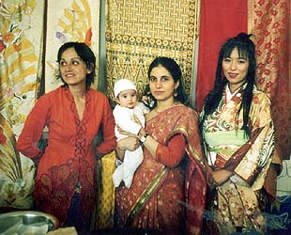
Introduction
Rathfarnham Educate Together National School’s first Intercultural Day took place on Sunday 8 June 2003. It aimed to be an enjoyable way to learn about different cultures and countries for children from the school, their families and friends, through learning about food, music and craftwork from a range of countries. It proved to be a tremendous success and this report explains how we went about organising and what we learned from the event.
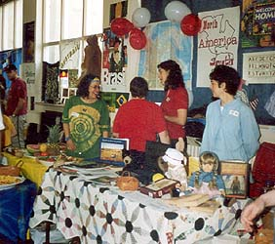
The Principal and staff of RETNS decided to hold the school’s first intercultural day in June 2003. They spent much of the year teaching the children about different cultures and preparing display materials. They approached the Parents’ Association for help in organising food and entertainment on the day. Only one of the Parents’ Association had ever been involved in something like this before, so she agreed to co-ordinate the social event with assistance from others in the group.
This report aims to assist other schools who are considering running an event like this, and for our school to use in organising future events of this kind. It does not look at the huge amount of work undertaken by the staff and children in the school which were essential in making the day such a success, as this was the responsibility of the staff.

Decisions to make at the start

Date and time
An afternoon at the weekend is the best time, preferably when you have a chance of good weather for people to go outdoors for part of the time.

Format
Parents from each region of the world were asked to prepare stalls with typical food, music, artefacts etc. Teachers and students prepared displays of their work throughout the school.

Venue
We decided to have all the stalls, food and entertainment in the large hall in the school, so that there would be a good buzz. The children’s work was to be displayed in downstairs classrooms and in the corridors.

How many stalls and for what regions of the world?
We wanted all regions in the world to be included. We decided to have seven stalls after considering the ethnic origins of parents and children in the school (Africa, Western Europe, Australia, The Americas, Asia, Eastern Europe, Ireland). We felt it was important to have an Irish stall for the benefit of people from outside Ireland.

Find someone to run each stall
The co-ordinator felt that the best way to spread the responsibility for the day and to involve as many people as possible was to find a stall leader for each of the stalls. Each stall leader was given the document “Guidelines for Stall Leaders”.

Find someone (or two people) to run a raffle
A raffle leader was appointed to source prizes, organise volunteers to sell tickets, organise the raffle on the day and distribute prizes following the event.

Find someone to look for donations of food etc for the event
This parent phoned potential donors and followed up with a letter where necessary. She contacted all who had agreed to donate food or items prior to the event in order to confirm delivery / collection details. She got volunteers to collect items where necessary. A poster listing all of the donors was placed prominently in the hall on the day and all donors were sent a thank you letter with the programme for the day following the event.

Put together a flier
This flier should go in school bags well in advance of the event so that everyone can keep the day free and so that people know what you are talking about when you ask for help! Try to find someone who is good at artwork to make it look attractive. List all the stall leaders, the raffle organiser and the donations organiser on the flier as well as the co-ordinator of the day. Be sure to mention if there is a charge involved in attending – we decided not to charge an entry fee so that no-one would feel they could not afford to come to the event.

List of parents from different cultures
The co-ordinator should make a list of all the parents he / she knows within the school from different cultures and ask them to get involved in the different stalls. Members of the Parents’ Association can help with this, as they should represent all the classes in the school.

Irish Stall | Entertainment
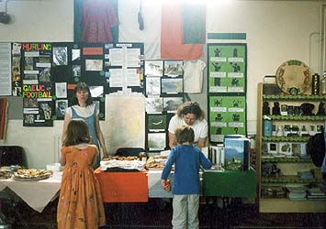 | 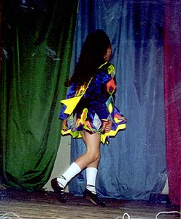
Western Europe Stall | Africa Stall
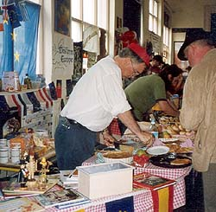 | 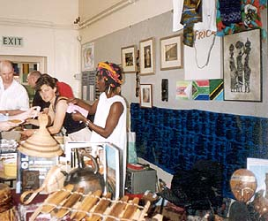

Tasks in the run-up to the event

Arrangements with school staff
The co-ordinator met the Principal on several occasions initially but later one teacher was nominated to link with the co-ordinator. This worked very well as she acted as the contact person with the other staff and was able to source materials which the Parents’ Association did not have easy access to. The link teacher helped in the following ways:
- Photocopied a large number of colouring sheets with a variety of ethnic themes for younger children, in case it rained.
- Sent a flier home looking for volunteers to provide entertainment during the event. This proved unsuccessful and we ended up asking people we knew to do things – which worked well.
- Ensured that rooms were available for the puppet show and the making of the St. Brigid’s crosses (Irish stall activity).
- Checked what socket boards, CD players, microwaves etc were available in the school. The co-ordinator then sourced additional items from other parents as required.
- Provided one large current world map to display in the hall and smaller maps at each of the stalls.
- Organised class teachers to provide text on the display materials they had for the event and the projects they had done during the year. This was included in the programme for the day.
- Ensured that a selection of bluetack, thumb tacks, sellotape, markers, scissors, card paper for signs and posters etc were available for the set-up of the stalls.
- Arranged for tables to be made available for the event. Each of the stalls had 2 tables (1 for food, 1 for artefacts and display material), refreshments, lollipop game (organised by one of the Special Needs Assistants), Fairtrade stand.
- The school caretaker set up the Burco, teapots etc in advance at the refreshments stall.

Arrangements with parents and volunteers
- One of the non-teaching staff went to the cash and carry and bought items that were needed which had not been donated (list prepared by co-ordinator).
- Volunteers were needed two days before the event to set up the venue (overall layout rather than working on specific stalls). (Ensure the school hall is kept free for this time and that it is not needed for any other activity before your event.)
- Someone with a key and the alarm code had to be available to open and close the school on the Saturday and early on the Sunday to accommodate volunteers who needed access.

Activities
- One parent offered to organise a plant sale and co-ordinated this herself.
- One parent organised boules to be played in the yard which proved popular. 5th Class children helped to supervise.
- The Garden Committee organised story telling in the garden.
- 6th Class organised quizzes etc in their classroom and the proceeds went to a charity they chose.
- Face painting was organised by 6th Class.
- One parent offered to put on a puppet show. This was held in the Junior Infants classroom. When outdoor activities were moved inside due to a rain shower, this parent ran an additional show.

Publicity
- The Principal drew up an invitation list and a flier was prepared by one of the parents to invite people to the event. All Educate Together schools were invited, also some parents who had been very active in the school in the past.
- The Junior Infants teacher handed out fliers to parents of children due to start the following September on the day the children came to the school on a visit in May.
- A very attractive poster was prepared by a member of the Executive Committee to advertise the event within the school. She also did the presentation work on the flier and the programme. It is very important to make the event look attractive and professional and her work was highly praised.
- The programme for the day was sent home on colourful paper in the school bags before the event. More programmes were available on the day.
- A banner / sign was prepared for each of the stalls with the name of the stall and an outline map of the region.
- A poster was prepared listing the donors.
- A poster was prepared by the raffle organisers listing the raffle prizes.
- Someone was asked to video the event and others were asked to take photos. It is important to have a record of the event. (Ensure you have someone on hand to take photos and a video of the event. Digital photos can be put on the website, but do not have close-ups of children on the site for safety reasons.)

Money
- Agree with the school Principal / Board of Management what the proceeds from the day will be used for and put this on the programme.
- Clarify who is paying for any items which need to be bought (school or Parents Assoc – in our case the school paid as the proceeds were going to the school).
- The school secretary organised a cash float of €20 in change for each of the seven stalls, the raffle organisers, the tea station and all other stalls.

Insurance
- The Principal confirmed that there was sufficient insurance for the event (school insurance policies should cover an event like this).

Donations
- The co-ordinator prepared a list of what might be needed for the person looking for donations two months in advance – this can be added to following discussion with the stall leaders. Many companies use up their charitable budget early in the year so you should ask as early as possible.
- Keep a list of donors for future reference. We have done so but are not circulating it with this report. We used a variety of methods – some people went to places they shopped regularly and asked for a donation, or asked friends who worked in food companies / shops etc to get things for them. Phoning companies with no contact person in advance proved surprisingly successful, as did calling into shops and asking for prizes.
- Some donations had to be collected during the week before the event.

Recommendations for the Future
Overall, the event was a tremendous success with a huge sense of involvement throughout the school and great fun on the day. For further details, see the article that was prepared for the school newsletter following the event.
There are always things that could be improved upon and the following is a list of some things that could be looked at in relation to a future event:
- Person to co-ordinate donations should be listed on flier and parents working for / in contact with food companies should contact this person directly
- The PA system in the school was very poor – a better one was needed
- All raffle tickets should have a phone number on the back – some prizes were not claimed as the people had left early (Have lots of books available, in different colours, so that you do not have to match code numbers)
- Someone is needed to co-ordinate the refreshments – set up the table, ensure there is enough of everything, organise a rota of volunteers for the duration of the event. The co-ordinator ended up doing much of this work, which was time-consuming.
- A second overall co-ordinator (or assistant) would be useful, as volunteers had lots of questions and the co-ordinator was not able to help them all as quickly as she would have liked.
- Ensure all areas of the world are included – we added the Middle East to the Asian stall and Russia to the Eastern Europe stall following discussion with parents from these areas.
- Story telling in the garden proved difficult because people were wandering around and the children would not sit down. It began to rain also which ended the activity. In future story-telling should take place in a classroom and an outdoor activity such as a treasure hunt should take place in the garden.
- Sponsorship should be looked for well in advance of the event. A school in another area got funding from their county council – this was not available in our area but other possible sources should be explored (e.g. Know Racism, Scheme A, Tel 4790271 might have helped us but we did not find out about it until just before the event. Unfortunately it will not be around next year).
- Guidelines should have been prepared for all volunteers on stalls as many of them went directly to the overall co-ordinator with queries rather than to their stall leader.
- A budget should be agreed with the school for entertainment – other schools have had live music which proved very popular
- The co-ordinator met the Principal on several occasions but towards the end one teacher was nominated to deal with the co-ordinator. This was very satisfactory as there were a lot of last minute issues to deal with which the Principal would not have had time for.
- Consider some activities with an ethnic touch e.g. competition to carry something on your head, braiding
- Consider producing a cookery book with recipes from different countries as a fundraiser
- Consider a Fair Trade stall (e.g. Oxfam)
- The invitation list and letter need to be prepared well in advance
- Aim to have the programme in the school bags the Wednesday before the event at the latest
- Prepare more detailed letters for potential donors and to thank donors.
- Get some outside publicity for the event in advance (if open to the public) and afterwards (send photos and an article to newspapers, local newsletters, radio stations etc.)

Appendix 5.1: Guidelines for Stall Leaders

Guidelines For Stall Leaders

Introduction
Rathfarnham Educate Together National School’s first Intercultural Day is taking place on Sunday 8 June from 2-5pm in the school grounds. It aims to be an enjoyable way to learn about different cultures and countries for children from the school, their families and friends, through learning about food, music and craftwork from a range of countries.

Organisation before the event
There will be seven stalls set up as follows: Ireland, Western Europe, Eastern Europe, Africa, Asia, Australia, the Americas. Some of the stalls will represent more than one country e.g. Asia so far has representatives from India, Japan, Malaysia and Pakistan.
You will act as a contact person for your stall. Your phone number will be circulated to all parents in the school in case they wish to volunteer to help you prepare your display, give you a loan of artefacts, help with cooking or on the stall etc.
Your stall will represent many countries, so you need to arrange a meeting to plan how to work together.
You need to tell Adrienne what your plan is for your stall before the last week in May at the latest, so we can prepare a small leaflet for everyone on the day telling them what to look out for. Remember to include everything that you plan to do. All of your ideas are welcome – some ideas might include teaching children games from your country, singing, dancing, storytelling, displaying craftwork etc. If you require money to pay for ingredients or other items for your stall, contact Adrienne. You will be expected to keep receipts for purchased items to make the Treasurer’s task easier at the end of the event.
You should not be out of pocket for becoming involved with running a stall.
You need to inform Adrienne before the last week in May at the latest of what you need in terms of equipment e.g. microwave, bain marie (for keeping food hot), CD player etc. If you are able to provide your own equipment, please let Adrienne know the number of electrical sockets you require.
We will provide a banner with the title of your stall, also a map in the hall marking all the countries represented. You need to prepare a display before the event. It would be great if this display included some flags, maps, pictures and some information on your region. Ideally you should have some crafts from the countries represented. We will ask people not to touch them but you should keep watch on items of your own or those given to you on loan for the day. The children may be able to help with the displays as part of their schoolwork during the week before the event. The school is planning a series of activities in the week leading up to the Intercultural Day, so you should speak to your class teacher or to Paddie, the principal, if you have any suggestions. You are welcome to bring along people who are not involved in the school but who share your culture or ethnic background to help you with this. You are also very welcome to involve your children or other children from the school on your stall, keeping in mind safety issues with regard to hot food, equipment etc.

Setting up your stall
You are welcome to set up your stall on Friday 6th during school time or on Saturday 7th (times to be arranged). If you want help in setting up your stall, please let Adrienne know. If you can arrange help yourself, that would be wonderful.
Each stall holder will be provided with two tables, one for displaying crafts, books, artefacts etc, and one for serving food.
The stall leader should ideally be on the school grounds for the entire event, or name someone as stall leader for part of the event. They should have a team of approximately five people to ensure that there are always two people on the stall. Team members should be available to serve food and talk to people about their display or to give information about their country / countries. No one should feel they have to stay at their stall all the time. You should organise the work so that each team member has an opportunity to look at other stalls and enjoy some free time.

On the day
All stalls should be ready before the event begins.
Stall helpers are encouraged to wear ethnic dress.
We will provide paper plates and serviettes. Soft drinks, teas and coffees will also be provided in the hall.
All food needs to be prepared in advance, ideally in small portions so that people can sample a variety of tastes.
Please be very conscious of health and safety issues at all times – we do not want anyone to be hurt at the event.
We will provide you with a float (of cash) at the start of the event so you have some change. You will be responsible for charging a small amount for food portions at the event, and this will all be handed over to the organisers at the end of the day to cover costs and hopefully to make some money for the school. Please discuss what you intend to charge with Adrienne well before the event.

After the event
You should hand over any money you have collected to the organisers.
You should ensure that all the crafts, food and equipment that you brought with you are removed from the hall before you leave. You can take down your display or we will do that for you.
You can relax and be glad that it is all over!
You are very welcome to speak to me in the school or to phone me to discuss any concerns you may have.
Thanks again for volunteering to help.

Best wishes

Adrienne Collins
Tel 298 6937

Appendix 5.2: Donations

Donations Being Looked For

This list was given to the person looking for donations for the day.

List of things needed for general use

Tea (ideally fair trade)
Coffee (ideally fair trade)
Sugar (lots, for candy floss machine also)
Milk
Biscuits, including plain ones
Dilutable drinks
Bottled water
Ice creams

Paper cups (or something suitable for teas etc)
Paper plates
Plastic cutlery
Serviettes
Cups with lids and straws may be available from McDonalds for children
Paper table-cloths for all the stalls and display tables
Paper bags for goodies

List of things for individual stalls
Ireland
- Smoked salmon
- Selection of Irish cheeses
- Butter
- Bread / scones / bracks etc
- Any other simple Irish foods you can think of
Americas
- Candy floss machine to be booked, sugar, colouring and cones needed
- Muffins / brownies / cookies
Western Europe
- French – crepes being made (flour, milk, eggs, choc sauce)
- German (salamis)
- Baked goods
- Cheese
Other stalls - Eastern Europe, Asia, Africa and Australia
- Baking goods, spices, vegetables,

Raffle prizes with ethnic touch (e.g. meal in foreign restaurant, vouchers for shops etc)

Appendix 5.3: Letters to Donors

Letter 1 sent to donors following contact by phone.

Dear Sir or Madam

I am writing to you further to our telephone conversation re Rathfarnham Educate Together National School’s first Intercultural Day which will take place on the 8th June. In our school we have children from several different cultures so this day aims to teach the children and their families about each other’s culture through food, music and craftwork. To enable to make this day a success we would appreciate a donation of product from your company.

Please do not hesitate to contact the school or myself at 1234567.

Regards

Letter 2 was sent or brought by volunteers looking for raffle prizes.

To whom it may concern

Rathfarnham Educate Together National School will be holding an Intercultural Day on Sunday 8th June. To raise money for the school, a raffle will be held on the day. Sara Isaacs is organizing this and is hoping to raise support from local businesses to donate prizes to this event.

Yours faithfully

Letter 3 was sent to all donors for the event and for the raffle, with a programme of events enclosed, following the Intercultural Day.

Dear

On behalf of the children, parents and staff of the school we would like to take this opportunity to thank you for your support for our first Intercultural day. The day was a huge success and was thoroughly enjoyed by all who attended. From the programme we have enclosed you can see how varied our stalls were. People were able to enjoy food from all around the world, which was partly made possible by your kind donation.

Again many thanks for your support and we look forward to contacting you in the future.

Regards,

--------------------
Intercultural Day Committee

Appendix 5.4: Can You Help Flier

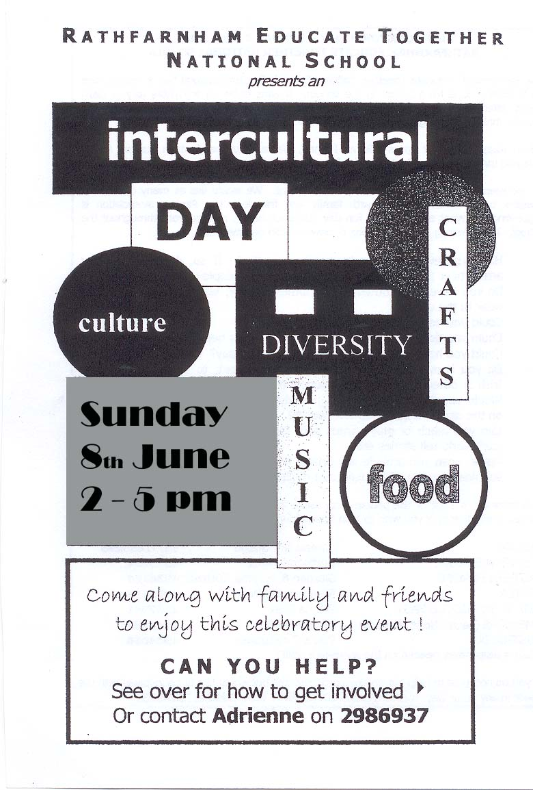 | INTERCULTURAL DAY – SUNDAY 8 JUNE 2003  RATHFARNHAM EDUCATE TOGETHER NATIONAL SCHOOL  The Rathfarnham Educate Together National School’s first Intercultural Day is taking place on Sunday 8 June in the school grounds. It aims to be an enjoyable way to learn about different cultures and countries for children from the school, their families and friends, through learning about food, music and craftwork from a range of countries.  There will be seven stalls set up as follows: Ireland, Western Europe, Eastern Europe, Africa, Asia, Australia, the Americas.  Please keep 8 June free to participate in this event. We would like as many children as possible to be involved, along with family and friends. The Parents’ Association will help out instead of running the annual school picnic but much help is needed from throughout the school. The following are suggestions of how you can get involved.  - Have you ever travelled to another country? If so, do you have any artefacts or music which you can loan to the people running a stall?  - Do you have any clothes from another country which you would like to wear to the event?  - Could you help set up a display?  - Could you do some cooking for one of the stalls before the event?  - Could you help out on one of the stalls on the day?  - Do you know how to play a musical instrument, to sing or to dance – Irish or otherwise, all talent welcome on the day.  - Would you like to be involved in setting up stalls, serving tea and coffee on the day or clearing up afterwards?  - Can you teaching or play games with the children, show them how to do craft work, tell stories etc  - Raffle – can you provide any prizes, particularly with an ethnic touch? (If so, please contact Sara at 4922929)  The following is a list of the people responsible for the seven stalls on the day. Please contact them directly if you wish to help them before or during the event.  IRELAND Sinead Ni Cofaigh  WESTERN EUROPE Bertrand Faust 4926294  EASTERN EUROPE Sladjan & Mirjana Kutjevac 4936164  AFRICA Manuela Madeira 4922904  ASIA Reena Rishi  AMERICAS (South, North, Canada) Cheryl Marling 4941407  AUSTRALIA Dave Christopher 4904056  If you do not want to help out on any particular stall but would like to be involved with the event in any other way, please contact Adrienne Collins at 2986937.

Appendix 5.5: Invitation Flier

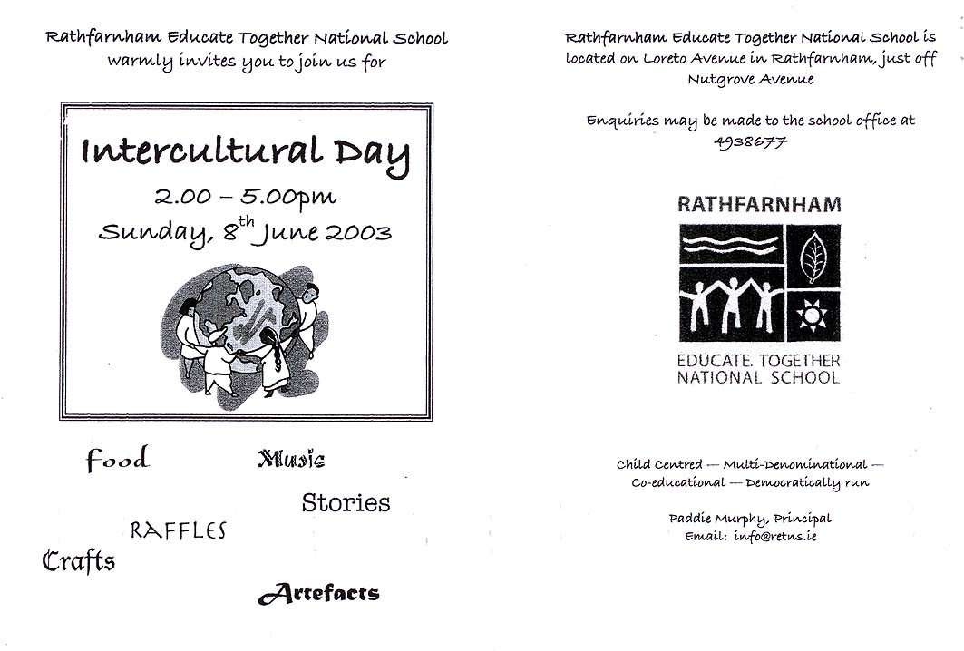

Appendix 5.6: Intercultural Day Programme
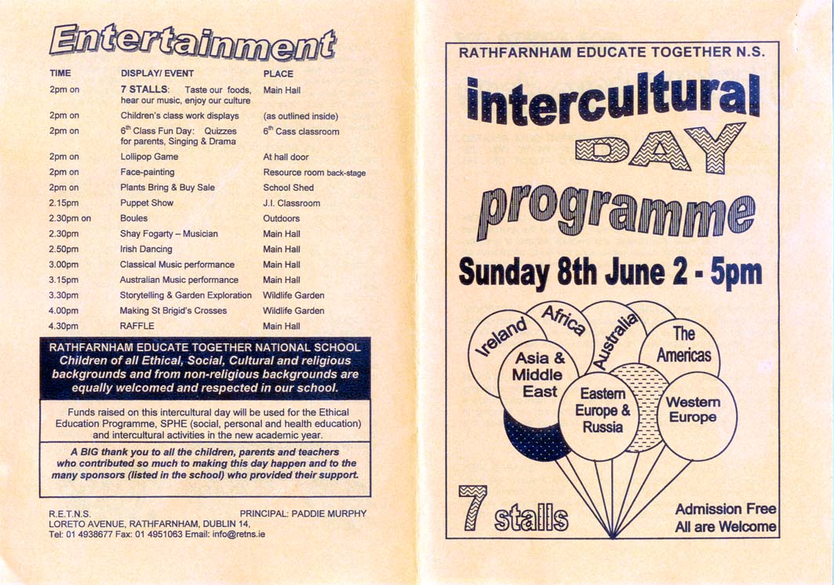

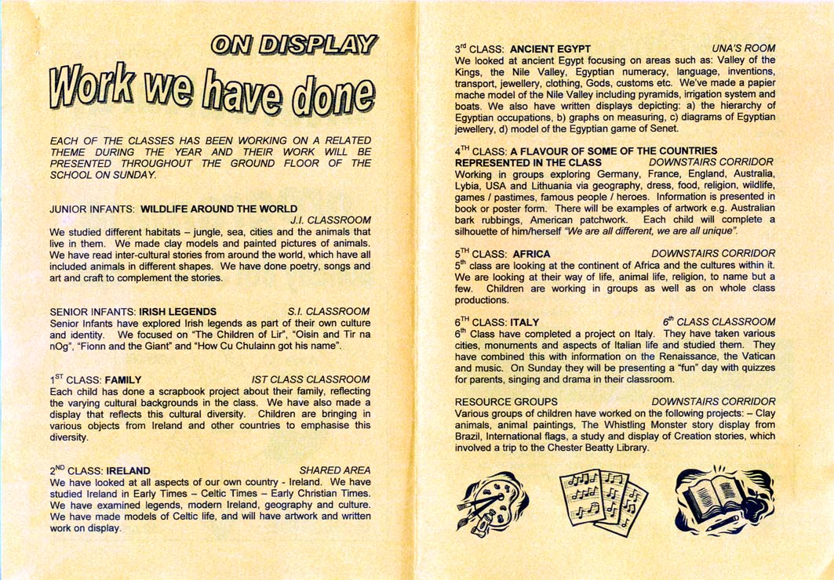

Appendix 5.7: Article for School Newsletter

HAPPY INTERCULTURAL DAY!

My daughter greeted me on the morning of Sunday 8 June with “Happy Intercultural Day” as we had talked of nothing else for days, and indeed it turned out to be a very happy day.

All the children in the school had been busy during the year learning about one or several cultures and prepared wonderful displays related to what they had learned. These were on display throughout the school in the classrooms and corridors. The children who came along to the event showed their work to family and friends and were very proud of what they had done. A full description of the work of each class was provided in a brochure circulated to all families before and at the event.

There was huge activity in the hall throughout the afternoon. The seven stalls representing Africa, the Americas, Asia and the Middle East, Australia, Eastern Europe and Russia, Ireland and Western Europe were a hive of activity. Each of the stalls had maps, artefacts, posters and books from the countries they represented so people could find out a bit about them. Helpers wore the traditional dress of their countries and looked very exotic and indeed wonderful in kimono, sari, Serbian and African clothes. Some of them also had musical instruments for people to try out. They also had background music playing on CD to liven up the atmosphere. However, I think the thing everyone was most interested in was the absolutely delicious food from around the world. There was an amazing variety including sushi, puri, falafel, breads, cheeses, fruit, samosas, stews, crepes, croissants, biscuits, toast and vegemite, muffins, cookies, meatballs, cakes … The candy floss proved extremely popular also, not to mention the ice-creams and drinks. We were spoiled for choice and all the food was wonderful. A huge thank you to the stall leaders and their helpers for putting together the displays, preparing the food, helping at the stalls throughout the afternoon and clearing up afterwards.

There was plenty of entertainment on the day also. Children from the school did Irish dancing and played classical music and parents sang and played music on the stage of the main hall. The Garden Committee organised storytelling and a tour of the Wildlife Garden. An excellent raffle was organised and great prizes were won on the day. Children made St. Brigid’s crosses, played the lollipop game and attended a very crowded puppet show that even involved limbo dancing! For those with an interest in gardening, some parents organised a plant sale in the yard, which was very successful. 6th Class organised a range of activities for visitors to their classroom as well as face painting in another room and some 5th Class children supervised games of boules in the shed.

The weather was wonderful for most of the afternoon so everyone was able to sit outside in the sun to enjoy the food and atmosphere, apart from a torrential downpour before the end. Thankfully it cleared up and people were able to go out again. The school was buzzing for the afternoon and people were very slow to leave at the end.

A marathon clean-up session followed and within an hour order had been restored and the counting of money began. The main aim of the day was to raise awareness of the many cultures represented throughout the school. However, we succeeded in raising over €1700 which will be used for the Ethical Education Programme, for Social, Personal and Health Education and also for intercultural activities in the future, so we can look forward to an exciting year!

I counted over 50 parents who volunteered (or who were begged by me!) to give their time and energy before, during and after the day, not to mention their partners and friends who had to take on more housework and childcare duties while they were busy! The day could not have been the success it was without their ideas, enthusiasm and hard work. The work of the children and all the staff throughout the school was also essential to making it such a great day. A big thank you to the many sponsors who generously provided food, samples of fair trade products and also raffle prizes for the event. And last of all, a big thank you to all the children and their families and friends who came along on the day.

Adrienne Collins

Section Six: Annual Events

New Junior Infants Parents’ Night
Parents of all children starting Junior Infants are invited to a meeting in the school in the spring before their children start. There are various speakers at this meeting: the Principal, representatives of the Board of Management and the Parents Association. The meeting itself is organised by the Principal, Deputy Principal and Board of Management.
The parents of the current year’s Junior Infants are responsible for preparing and serving the teas/coffees after the meeting.

Set Up
School staff generally set up the Junior Infants classroom in preparation for the meeting. We have used the Junior/Senior Infants shared area and the First Class classroom for serving tea in the past. This can be set up in the afternoon before the meeting (i.e. after 1.30 when JI/SI children are finished). It is helpful if a parent is available to help staff to set up the tea room.
Ensure that box of cups & saucers etc. is taken out of the cupboard and brought into the classroom when setting up. If not, ensure that someone has keys to the green cupboard (under the stairs at the side door of the school) so the cups & saucers can be retrieved. (The Principal and school caretaker have keys to this cupboard, but Principal will be in the meeting and caretaker may not be in the school on the night.)
Ask school caretaker to move the Burco boiler into the room and if possible to plug it in.

Supplies
- Cups & Saucers / plates for biscuits. There are two plastic boxes in the green cupboard - these belong to the Parents Association – one of them is full of cups & saucers.
- Teapots – there are two small teapots in the staff room. If possible, borrow a large teapot (we have borrowed one from community centre).
- Coffee, tea, sugar (check the PA box in the green cupboard and/or the staffroom – there should be a box of teabags, lots of sugar sachets and possibly coffee)
- Milk – 2 litres
- Biscuits – 4 or 5 packets of biscuits
- Paper table cloths / table cloths / tea towels / washing up liquid

Team
One Junior Infant parent should be responsible for organising a small team. At most you will need 4 parents.
One parent should arrive early (before the meeting begins at 7.30) to begin preparations (i.e. check that Burco is plugged in) and to get an idea of the time the meeting is expected to be over. Other parents can arrive after the meeting has begun and help to set up cups and saucers, biscuits etc.
Two or three members of the team should be pouring coffee / tea once the parents come out of the meeting. They should mingle with the new parents once everyone is served.

Washing up
We usually wash the dishes by hand in the staff room, and then pack all the dishes away in the PA boxes. This means that the job is finished and no one has to face it the next day! Because the teachers usually use the dishwasher, you may find that there is no washing up liquid or tea towels – be prepared and bring your own.
However, if someone from the team is available to come to the school first thing the next morning to empty the dishwasher, you can use the dishwasher in the staff room.
After the meeting is over, it is nice if the team can help the other organisers to put away the tables and chairs and help get the classrooms ready/back to normal for the next day.

School Social Event – Fun Day
At the end of each school year, the Parents Association organises a social event for the whole school: children, teachers, staff, family and friends. Over the years, we have had picnics at Marlay Park, Pine Valley and in the school grounds. In 2003, we held the Intercultural Day.
In 2004 we ran a Fun Fair, which was a social event as well as a fundraising opportunity. Here are some notes on how we organised this fun day.

Decisions to make at the start
We formed a small committee of three people to organise the fun day – this group met on several occasions to brainstorm and plan the event, and of course were available on the day to help out.

Date and time
The school fun day is usually held on a Sunday afternoon in the middle of June. Our 2004 Fun Fair was held from 2.30 to 4.30 in the school and on the school grounds. Our 2004 Fun Fair was run in conjunction with the school Cake Sale for the first time. The Cake Sale is organised by two parents in the school who are not on any committee.

Format
We wanted to have outdoor and indoor events, some which would be free, others to raise funds for the school.

Venue
We decided to have all the stalls, the raffle and the Cake Sale in the large hall in the school. Outdoor activities were held in various places around the school. We felt it was important to utilise the wildlife garden, and several activities were planned for this area.

How many stalls should we have / what activities should we run?
We wanted to have a variety of fun things for everyone to do. The committee brainstormed and wrote down as many ideas as possible, then spent time planning how to organise each stall and how to find people to run each one.

Find someone to run each stall
All of the stalls and activities had their own stall leader, who organised their team and planned their own rota. Sixth class children helped to run some of the stalls.

Find someone (or two people) to run a raffle
We found a raffle leader to source prizes, organise volunteers to sell tickets, organise the raffle on the day and distribute prizes following the event.
Our raffle leader was so successful at sourcing prizes that we had zillions of small prizes. So, the Spin the Wheel game was born. Everyone was a winner!

Put together a flier
This flier should go in school bags well in advance of the event so that everyone can keep the day free and so that people know what you are talking about when you ask for help!

Tasks in the run-up to the event

Arrangements with school staff
The co-ordinator met the Principal to discuss what would be needed on the day. The school caretaker was also on hand to help set up the hall, which was a great help.

Arrangements with parents and volunteers
- One of the non-teaching staff went to the cash and carry and bought items that were needed which had not been donated (list prepared by co-ordinator).
- Volunteers were needed on the morning of the event to set up the venue (overall layout rather than working on specific stalls).
- Someone with a key and the alarm code had to be available to open and close the school early on the Sunday to accommodate volunteers who needed access.

Activities
The fundraising stalls in the hall included:
- Bake Sale
- Raffle
- Spin the Wheel
- Pluck-a-Duck
- Guess the number of sweets in the jar
- The Lollipop Game
- The teacher’s quiz
- Bingo
Fundraising activities outside included:
- Plant Sale
- Boules
- Sponge Throw
The fun activities included:
- Treasure Hunt in the wildlife garden
- Games in the wildlife garden
- The Fun Fair Mural
- Races (running races, sack races, egg & spoon races)
We also planned to have crafts and a puppet show, but unfortunately the two volunteers who organised these events were unable to attend on the day.

Publicity
- A flier went home in the school bags to invite people to the event.
- Posters were placed in various points around the school, where parents and children would see them.
- The programme for the day was sent home in the school bags just before the event. The Teachers Quiz was attached to the programme, for discussion with families and friends.

Money
- Agree with the school Principal / Board of Management in advance what the proceeds from the day will be used for and put this on the programme.
- Clarify who is paying for any items which need to be bought (school or Parents Assoc – in our case the school paid as the proceeds were going to the school).
- The school secretary organised cash floats for all of the fundraising stalls.

Recommendations for the Future
There are always things that could be improved upon and the following is a list of some things that could be looked at in relation to a future event:
- The invitation list and letter need to be prepared well in advance
- Co-ordinator should keep a list of what items were borrowed from which classroom (for instance, 1 small chair from junior infants, 2 tables from senior infants). This list can then be checked at the end to ensure that everything is put back where it was taken from.
- A clean-up team should be appointed before the event. They should know what time they need to be on hand, and that they will need to stay until the end. One person should be responsible for checking that everything is properly put away and everything locked up.
- A counting-up team should be appointed before the event. They will have to count and bag all of the money, which is very time consuming.
- A plan for bringing the money to the bank should be put in place – where will the money be kept overnight? Will the bank accept a large amount of change? Should it be put into the PA account and then a cheque presented to the school, or should the money be handed over to the school directly?

School Sports Day – Obstacle Course
It is the tradition in our school that Second Class parents set up and run the obstacle course on the school sports day. The staff organise the other activities, with one teacher having overall responsibility. The following is a description of what is involved in organising the Obstacle Course:
1. You have to think about the layout of the course. It should be a bit different each year, to create a challenge

In 2004 the children had to do the following:
- Put on a football bib and a sombrero hat
- Run through 4 car tyres
- Walk along a bench (from school hall)
- Crawl through a play tunnel
- Jump a number of times on small play trampoline while balancing a tennis ball on a tennis racquet
- Crawl through another play tunnel
- Dribble a football through some football cones
- Kick (or throw in the case of the little ones) the ball at about
- Ten 2 litre plastic bottles filled with water
- Run back to the start line
- Pass the bib and sombrero to the next team member so they can start their turn.

2. You need to send out a request to the parents for the items that you need for the obstacle course. Remember you will need enough items to run two teams simultaneously.
Parents can leave the necessary items in the office or seek out the organising parents.

3. You will need help! Send out a request for parents to help throughout the day. You need at least 6 parents to be there at all times. A well-planned rota will ensure that one group of parents don’t get stuck there for the whole day. You will probably have to chase after parents to organise the rota.

4. You need to talk to the teacher in charge of sports day. This teacher organises the timetable for the sports day and you can get a copy from them showing which class will be coming along next (and what time breaks are at - remember to bring food and refreshments as you will need them!) Each class gets approximately 30 minutes for the course - sometimes more, sometimes less. The teacher will divide the class into 4 groups (depending on class size).

5. You need to set up the course at the allocated space at the school on the morning of the sports day.

6. Get ready for the fun!
Two teams run through the course at a time. If there is enough time the 2 winning groups can go against each other or just run the groups through again if you don’t want it to get too competitive!
The little ones will need more help than the bigger ones to get through the course and it can get quite lively.* Even though it is not supposed to be competitive, it gets very noisy as each team cheers on their members so they can win!!

* The course can be made easier, if required.

Other Annual Events
There are some other activities that occur each year. The parents of specific classes are generally responsible for organising these activities (for example, 5th class parents organise the 6th class leaving party). These are not necessarily organised by the Parents Association, but we felt it worthwhile to include them here.

Communion / Confirmation
Our Parents Association is not involved in the organising of extra-curricular religious instruction. This is done by interested parents in the relevant classes. The parents of the children involved in next year’s Communion/Confirmation prepare the teas/coffees for this year’s Communion/Confirmation class.

Sixth Class Leaving Party
The parents of fifth class are responsible for organising the end-of-year party for sixth class and their parents.

Gifts
At the end of the school year, gifts are given to the principal, school secretary and school caretaker. Gifts are also given to teachers who are leaving the school. The type and amount of gift is agreed upon by the Parents’ Association.
These gifts are paid for from PA funds – there is a small surplus built into the cost of extra curricular classes to cover these expenses.

Appendix 6.1: Can You Help at the Fun Fair Flyer
  Rathfarnham Educate Together National School  Fun Fair  Sunday 13 June 2004  2.30 to 4.30  Come along with family and friends to enjoy this school event | FUN FAIR – SUNDAY 13 JUNE 2004  RATHFARNHAM EDUCATE TOGETHER NATIONAL SCHOOL  Can you help?  Rathfarnham Educate Together National School’s annual summer event is taking place on Sunday 13 June in the school grounds. This year we plan to have a Fun Fair, which will give children from the school and their families a chance to meet and have some fun and also to raise funds for _______  There will be a bake sale, a plant sale and several fun stalls, including: pluck-a-duck, raffle, spin the wheel, guessing games and face painting.  There will also be fun events in the school grounds, including: games in the wildlife garden, score a goal, the fun fair mural and lots of races – including sack races for the parents!  The Parents’ Association is running this event but much help is needed from throughout the school. Please contact us if you can help with any of the following:
  Cake Sale & Refreshments | ⇨ | Pauline & Eimer at the after school facility
  Raffle and tombola prizes | ⇨ | Nikki | 4935705
  Plant Sale | ⇨ | Mary | 4905728
  Helping at stalls on the day | } | Liza | 086 8313369
  Running games or events | } | Trish | 085 7026876
  Setting up and taking down | } | Adrienne
  Cake Sale
  Can you bake? Pauline & Eimer are looking for everyone who can make a commitment to bake cakes and goodies for the cake sale. Or, perhaps you know someone who might donate baked goodies
  Prizes
  We need lots and lots of prizes – big and small, for children and for adults.

Appendix 6.2: Fun Fair Flyer

Rathfarnham Educate Together
National School

Fun Fair
Sunday 13th June 2004
2.30 to 4.30
Come along with family and friends to enjoy this funtastic fundraising afternoon.
Any questions or suggestions, contact Liza (086 8313369)

Raffle Prizes
We need lots and lots of prizes – big and small, for children and for adults.

Please drop any raffle prizes into Carol in the office.

If you have any queries contact Nikki (4935705)

Appendix 6.3: Fun Fair Posters

Rathfarnham Educate Together National School
Fun Fair
Sunday 13th June 2004
2.30 to 4.30
Come along with family and friends to enjoy this funtastic fundraising afternoon.

Appendix 6.4: Schedule of Events

RETNS Fun Fair - Schedule of Events
Time | Event | Where
2.30-3.00 | Crafts in Shared Area | Inside
3.00-3.30 | Puppets in Junior Infants | Inside
3.30-3.50 | Bingo in Hall | Inside
4.00 | Result of Teachers competition | Inside
4.05 | Tombola / Raffle in Hall | Inside
2.30 | Boules | Outside
3.00 | Races (older children?) | Outside
3.20 | Races (adults?) | Outside
3.30-4.00 | Treasure Hunt in Garden | Outside
3.45 | Races (younger children?) | Outside
4.00-4.30 | Hide & Seek in Garden | Outside
Indoor Stalls  Cake Sale  Refreshments  Pluck-a-Duck  Guess the Sweets in the Jar  Lollipop Game  Tombola  Raffle  Face Painting | Outdoor Games and Stalls  Sponge Throw  Candy Floss  Score a Goal  Fun Fair Mural  Boules  Races  Garden Games

Appendix 6.5: Teacher’s Quiz

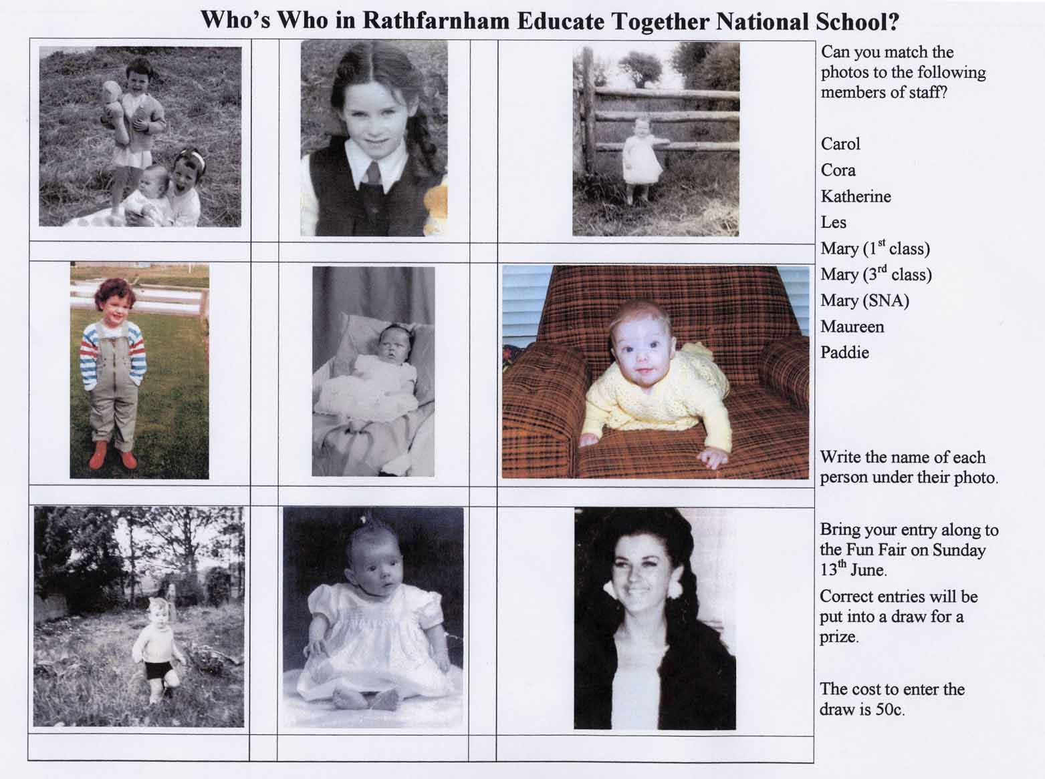

Appendix 6.6: Floats

Floats

Cake Sale in the Hall  Refreshments (Tea / Coffee)  Bingo in the hall: €1 for 5 cards (10 games) | Raffle in the hall: tickets 50c or 5 for €2  Pluck a Duck game: 20c  Guess the number of sweets in the jar: 20c | Lollipop Game: 20c  Buzzer game: 20c  Sponge Throw: 20c | Score a Goal: 20c  Guess the Teacher: 50c  Ice a Bun: 50c
  2 | €10
  4 | €5
  10 | €2
  10 | €1
  10 | 50c | €75
  10 | 50c
  10 | €2
  10 | €1
  2 | €5 | €35
  10 | €2
  10 | €1
  2 | €5 | €30
  10 | 50c
  10 | €2
  10 | €1
  2 | €5 | €35
  20 | 50c
  20 | 20c
  20 | 10c | €16
  20 | 50c
  20 | 20c
  20 | 10c | €16
  20 | 50c
  20 | 20c
  20 | 10c | €16
  20 | 50c
  20 | 20c
  20 | 10c | €16
  20 | 50c
  20 | 20c
  20 | 10c | €16
  20 | 50c
  20 | 20c
  20 | 10c | €16
  10 | 50c
  10 | €2
  10 | €1
  2 | €5 | €35
  10 | 50c
  10 | €2
  10 | €1
  2 | €5 | €35

Appendix 6.7: School Sports Day Letter

Sports Day Thursday June 17th

Dear Parent/Guardian,

It’s that time of the year again-sports day. As tradition has it, 2nd class parents organise & run the obstacle course and we need some help.

Items needed:
5 x 1 litre or 2 litre plastic bottles with lids
4 play tunnels

Any parents available to help on the day(for any length of time) would be greatly appreciated.

Please contact
Sinead (junior, 2nd,4th) ph:
Eileen (junior, 2nd ,3rd) ph:

Acknowledgements

Working on this manual has been great fun and I look forward to adding to it and updating it regularly. Any work like this is a collaborative effort and I would like to thank everyone who participated in its creation, including:
the writers, Adrienne Collins, Cheryl Marling and Sinead Cahill
members of the committee who checked, rechecked and corrected, especially Adrienne Collins and Julia Rowan
our former PA Chairpersons: Helen Conway and Úna Hennessy
our Principal, Paddie Murphy
and Lisney for the helping us in printing / copying and binding this manual.

Liza Toye
Chairperson,
Rathfarnham Educate Together National School Parents’ Association

September 2004

Printing and binding  sponsored by Lisney | 

See Appendix 2.1: AGM poster – page 8
See Appendix 2.3: Reminder – page 10
See Appendices 2.1 and 2.2: AGM posters – pages 8 and 9
See Appendix 2.4: Treasurer’s report – page 11
See Appendix 2.5: Chairperson’s address – page 12
See Appendix 2.6: Dept of Ed guidelines for election of parent reps – page 17
See Appendix 2.7: Sample agenda – page 20
See Appendix 2.8: Committee contact details – page 21
See Appendix 2.4: Treasurer’s report – page 32
See Appendix 3.1: Letter confirming insurance cover – page 30
See Appendix 3.2: Timetable – page 31
See Appendix 3.3: Note to parents – page 32
See Appendix 3.4: Code of behaviour – page 33
See Appendix 3.5: Class vouchers – page 34
See Appendix 3.6: Waiting list – page 35
See Appendix 3.7: Excel control sheet – page 36
See Appendix 3.8: Teacher guidelines – page 37
See Appendix 3.9: Ethos guidelines – page 39
See Appendix 3.10: Supervisor guidelines – page 40
See Appendix 3.9: Ethos guidelines – page 39 and Appendix 3.4: Code of behaviour – page 33
See Appendix 5.1: Guidelines for stall leaders – page 53
See Appendix 5.1: Guidelines for stall leaders – page 53 and Appendix 5.2: Donations – pages 55
See Appendix 5.3: Letters to donors – page 56
See Appendix 5.4: Can you help flier – page 58
See Appendix 5.5: Invitation flier – page 59
See Appendix 5.5: Invitation flier – page 59
See Appendices 5.4, 5.5 and 5.6 – pages 58, 59 and 60
See Appendix 5.6: Intercultural day programme – page 60
See Appendix 5.3: Letters to donors – page 56
See Appendix 5.7: Article for school newsletter – page 62
See Appendix 6.1: Can You Help at the Fun Fair Flier – page 73
See Appendix 6.2: Invitation flier – page 74
See Appendix 6.3: Fun Fair Posters – page 75
See Appendix 6.4: Schedule of Events – page 76
See Appendix 6.5: Teachers Quiz – page 77
See Appendix 6.6: Floats – page 78
See Appendix 6.7: School Sports Day Letter – page 79

